

SOFTWARE DESIGN SPECIFICATION

AITA-INTELLIGENT

AI-Powered Teaching Assistant & AST Code Analytics Platform
Version: 1.0

Prepared by: Group 4
Members:
- QE190151 – Lê Nguyễn Ánh Mai
- QE180099 - Nguyễn Tường Vy
- QE190030 - Nguyễn Quốc Thanh Phong
- QE190122 - Đỗ Trần Đăng Khoa
- QE190149 - Đinh Gia Huy

Course: SWD392 – Software Design Project

– – QuyNhon, September 2026 – –

TABLE OF CONTENTS
I. Requirement Specification
1 Problem description
2. Major Features
2.1 Features for Student
2.2 Features for Lecturer
2.3 Features for Admin
3. System context
4. Nonfunction Requirements
5. Functional requirements
5.1.1 Overview Use Case Diagram
5.1.2 Student Use Case Diagram
5.1.3. Lecturer Use Case Diagram
5.1.4 Admin Use Case Diagram
5.2 Use case descriptions
5.3 Activity diagrams
6. Data Requirements
II. Analysis models
1. Interaction diagrams
2. State diagram
III. Design specification
- Integrated Communication Diagrams
- System High-Level Design
- Component and Package Diagram
- Detail Design
- Database Design
IV. Implementation
- Map architecture to the structure of the project
- Map Class Diagram and Interaction Diagram to Code
V. Applying Alternative Architecture Patterns
- Applying the service-oriented architecture
- Applying Service Discovery Pattern in the service-oriented architecture

I. Requirement Specification

1. Problem Description
Purpose: Build the AI-powered Teaching Assistant System (AITA) to automate code evaluation, optimize academic workflow, and support continuous learning for IT courses at FPT University. The system streamlines course administration, assignment submission, automated code execution within secure environments, AI-assisted grading, peer-to-peer auditing, and interactive AI tutoring. The detailed system requirements based on the domain model (14 ERD entities) are described as follows:
- User & Course Management: The system manages users (users), courses (courses), teams (teams), and team membership (team_members). Users log into the system with role-based access control (Admin, Lecturer, Student). Each course has a code, name, semester, and is assigned to a lecturer. Lecturers manage student teams associated with a specific course and a shared Git repository (repo_url). Students joining a team are assigned a specific module (assigned_module) to track individual accountability.
- Assignment & Rubric Configuration: Lecturers set up assignments (assignments) for courses with titles, descriptions, deadlines, and maximum scores. For each assignment, lecturers define detailed rubric rules (rubric_rules), specifying rule types (automated/manual), criteria, input/expected output data, weights, maximum scores, and a visibility flag (is_hidden) to conceal specific test cases from students.
- Submission & Async Grading Execution: Teams submit their work (submissions) by providing an artifact URL (artifact_url) and Git commit hash (git_commit_hash), recording the submission timestamp and status. Once submitted, the system queues an asynchronous grading job (grading_jobs) with an assigned priority level, linked prompt template (prompt_template_id), and AI API key (ai_api_key_id). The code is executed within an isolated Docker sandbox container (sandbox_container_id), tracking queueing and completion timestamps.
- Grading Evaluation Results: Results of each grading job are stored as individual detailed records (grading_results) per rubric rule. Each entry records the score obtained, actual output from the sandbox, pass/fail status (passed), execution time, qualitative AI-generated feedback (ai_feedback), and an indicator of whether the result was generated by AI (is_ai_generated).
- Git Commit Analytics: To maintain individual transparency and prevent free-riding, the system collects repository commit logs (git_commits). It stores the commit hash, author (author_user_id), commit message, commit timestamp, and lines added/deleted (lines_added, lines_deleted).
- Peer-to-Peer Audits: Team members conduct peer evaluations (peer_audits) across specified audit rounds (audit_round). Reviewers assess reviewees by assigning scores, detailed comments, and a final pass/fail status (passed).
- AI Tutoring Chat System: Students can exchange interactive tutor chat messages (tutor_chat_messages) directly linked to a specific submission to receive code explanations and debugging assistance. Each message records the sender type (Student vs. AI), message content, creation timestamp, and references the specific prompt template and AI API key used to generate response guidance.
- AI Infrastructure & Resource Management: System administrators and lecturers manage a pool of AI API keys (ai_api_keys) across multiple providers. The system tracks key status, encrypted key values, rotation timestamps (rotated_at), and usage counts (usage_count) to optimize API costs. System prompt templates (prompt_templates) are maintained with explicit names, purposes, template contents, and version numbers for grading and tutoring consistency.

2. Major Features
2.1 Features for Students (Learners / Team Members)
- F01: Team Management: View team details (team name, repository URL), member list, and assigned modules (assigned_module) for each team member.
- F02: Assignment & Submission Management: View course assignment details (title, description, deadline, max score), submit assignment artifacts on behalf of the team (artifact URL, Git commit hash), and track submission history and status.
- F03: Grading Result Viewing: Access detailed evaluation results per rubric criterion, including criteria scores, sandbox outputs, execution durations, pass/fail status, AI feedback, and AI-generation flags (is_ai_generated).
- F04: AI Tutor Chat: Exchange interactive messages (tutor_chat_messages) attached directly to specific submissions to receive automated code explanations and guidance.
- F05: Peer-to-Peer Audit: Execute peer audits on designated team members across audit rounds (submit scores, comments, pass/fail decisions) and view personal audit results.
2.2 Features for Lecturers
- F06: Course Management: View assigned courses (course code, course name, semester) and manage course configurations.
- F07: Assignment Management: Create, update, and manage course assignments (title, description, deadline, max score), and attach prompt templates for automated evaluation.
- F08: Rubric Rule Management: Define and modify grading criteria per assignment (rule type, criterion description, input/expected output, weight, max score, hidden test toggle).
- F09: Team Management: Create student teams for a course, enroll students, and assign specific modules (assigned_module) to each member.
- F10: Submission & Grading Monitoring: Track team submissions, trigger or monitor asynchronous grading jobs (grading_jobs), and review detailed execution scores and AI feedback.
- F11: Git Contribution Tracking: Inspect member commit histories (git_commits) including commit messages, timestamps, and lines added/deleted to evaluate individual contributions.
- F12: Peer Audit Oversight: Monitor peer review scores, review comments, and check pass/fail compliance across audit rounds.
2.3 Features for System Administrators
- F13: User Account Management: Manage user profiles, create new accounts, and assign system roles (Admin, Lecturer, Student).
- F14: Course & Instructor Assignment: Create new courses and assign lecturers to corresponding courses.
- F15: AI API Key Management: Administer the pool of AI API keys (add keys, manage providers, toggle status, track usage counts, and handle key rotations).
- F16: Prompt Template Management: Create, update, version control, and maintain system prompt templates (prompt_templates) used for automated grading and AI tutoring.
3. System context
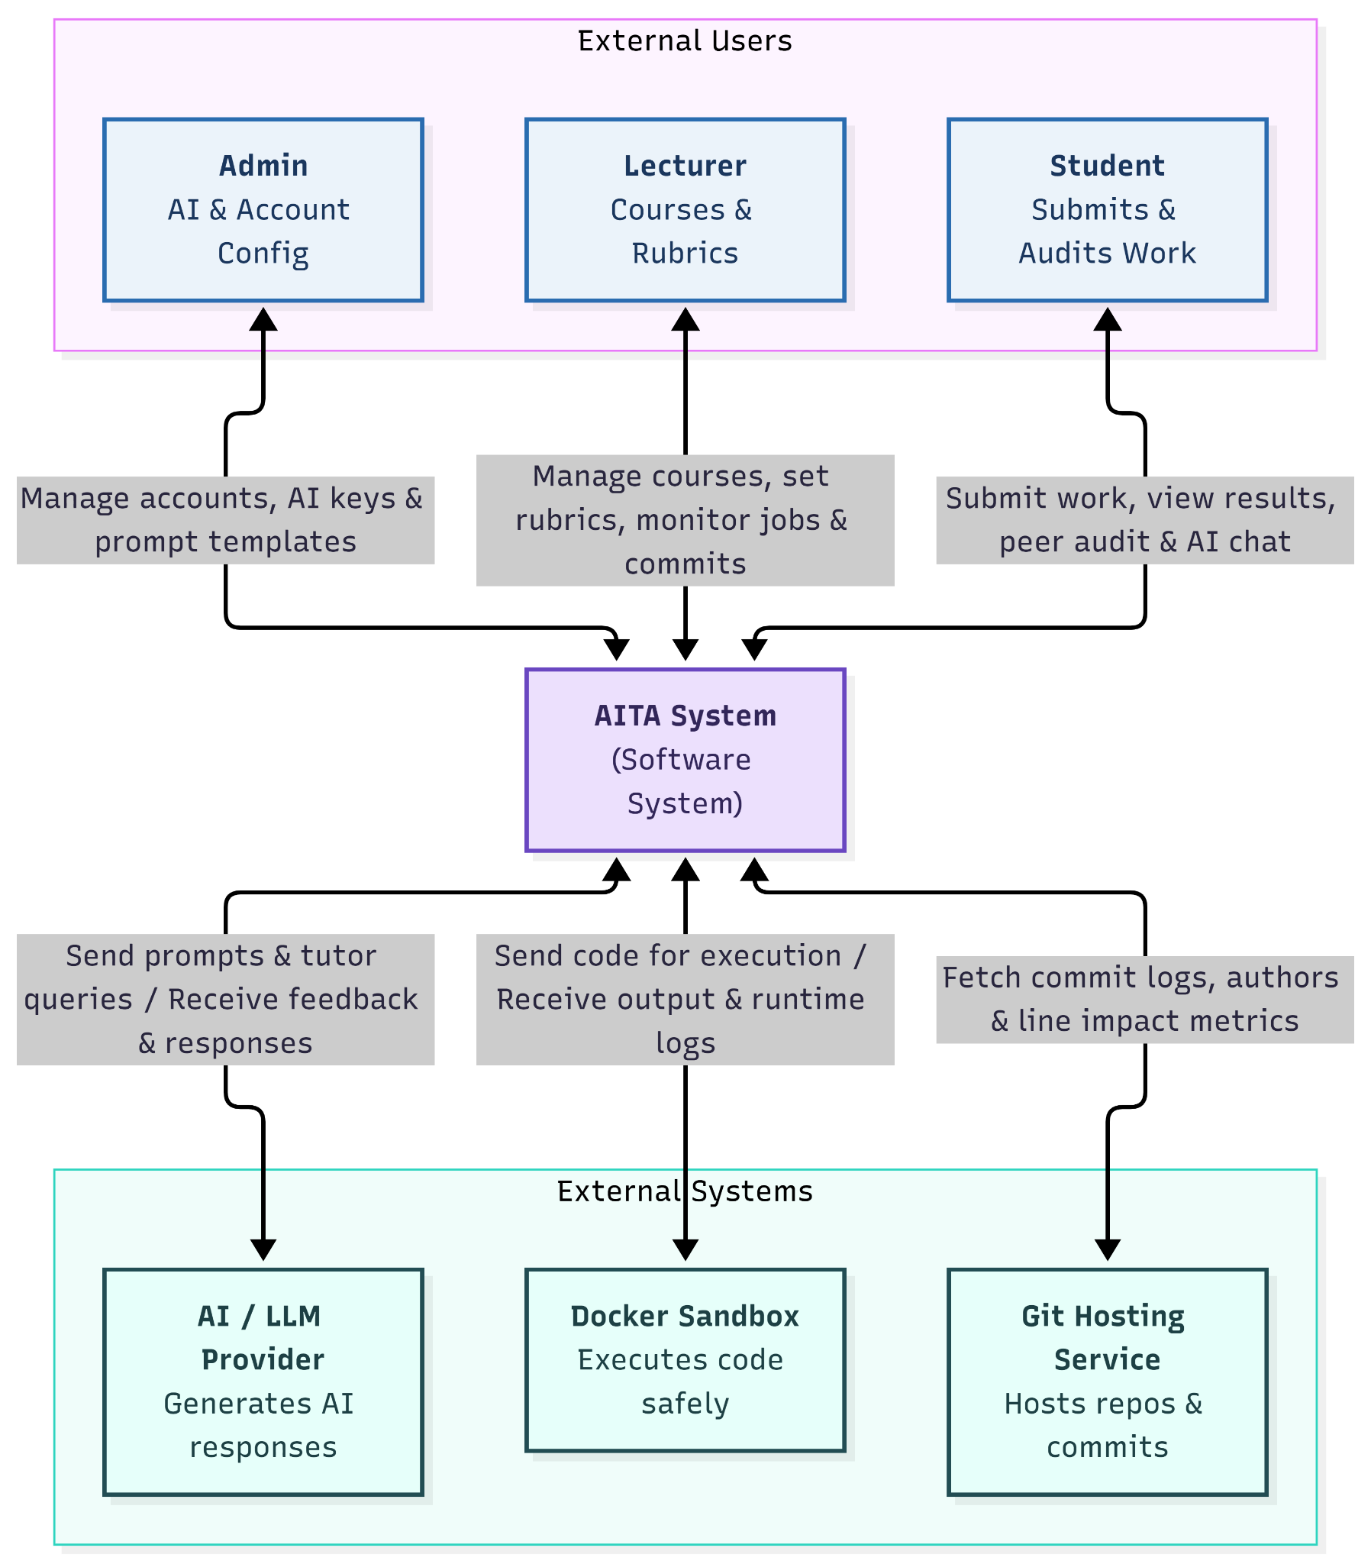
The System Context Diagram (C4 Model - Level 1) illustrates the high-level boundary of the AITA (AI-powered Teaching Assistant System), identifying the primary external users who interact with the system and the external software services that AITA integrates with to execute its operations.

3.1 External Users (Tác nhân người dùng)
- Admin (AI & Account Config):
  - Interaction: Manage accounts, AI keys & prompt templates.
  - Description: Responsible for system-wide configuration. Admins create and update user accounts with role-based permissions, manage the pool of AI provider API keys (including key rotation and usage tracking), and maintain versioned AI prompt templates.
- Lecturer (Courses & Rubrics):
  - Interaction: Manage courses, set rubrics, monitor jobs & commits.
  - Description: Interacts with the system to set up courses, define assignments, configure detailed rubric criteria (including hidden test cases), monitor background grading pipeline jobs, and inspect Git contribution logs to ensure academic integrity.
- Student (Submits & Audits Work):
  - Interaction: Submit work, view results, peer audit & AI chat.
  - Description: Submits project artifacts and Git commit hashes on behalf of their team, reviews detailed automated and AI-generated grading results, conducts peer-to-peer audits across assessment rounds, and interacts with the AI Tutor for code explanations.

3.2 External Systems (Hệ thống tích hợp bên ngoài)
- AI / LLM Provider (Generates AI responses):
  - Interaction: Send prompts & tutor queries / Receive feedback & responses.
  - Description: External large language model APIs (such as OpenAI, Google Gemini) invoked by AITA using managed API keys to evaluate rubric rules, generate qualitative code feedback, and power the interactive AI tutoring chat system.
- Docker Sandbox (Executes code safely):
  - Interaction: Send code for execution / Receive output & runtime logs.
  - Description: An isolated, secure container environment where student-submitted source code is compiled and executed against automated test suites. It returns actual execution outputs, runtime durations, and pass/fail statuses to the grading engine.
- Git Hosting Service (Hosts repos & commits):
  - Interaction: Fetch commit logs, authors & line impact metrics.
  - Description: External code hosting platforms (e.g., GitHub, GitLab) connected via repository URLs to retrieve commit histories, commit hashes, author information, and code modification metrics (lines_added, lines_deleted) for individual contribution tracking and anti-free-riding analysis.

4. Non-Functional Requirements (NFRs)

4.1 Performance Requirements
- NFR-PER-01 (API Response Time): The web user interface must respond to general HTTP requests (e.g., viewing courses, browsing assignments, reading grading results) within 2.0 seconds under normal operating conditions.
- NFR-PER-02 (Concurrent Users): The system must support at least 500 concurrent active users (Students, Lecturers, Admins) during peak submission windows without exceeding a 5% increase in response latency.
- NFR-PER-03 (Sandbox Code Execution): The Docker Sandbox environment must enforce strict execution timeouts (maximum 10–30 seconds per test case) to prevent infinite loops, memory leaks, or Denial of Service (DoS) attacks from malicious or inefficient student code.
- NFR-PER-04 (Grading Job Queue Processing): The background grading queue (grading_jobs) must process submitted jobs asynchronously. For standard submission batches, the execution, AI feedback generation, and result storage must complete within 3 minutes per submission.

4.2 Security & Data Privacy Requirements
- NFR-SEC-01 (Authentication & Authorization): The system must implement Role-Based Access Control (RBAC) enforcing strict separation of permissions among Admin, Lecturer, and Student roles. All passcodes/passwords must be hashed using strong industry algorithms (e.g., bcrypt or Argon2).
- NFR-SEC-02 (Encrypted Key & Token Storage): Third-party AI Provider API keys (ai_api_keys) and sensitive credentials stored in the database must be encrypted at rest using AES-256 encryption (key_value_encrypted).
- NFR-SEC-03 (Container Isolation / Sandbox Security): Code execution inside the Docker Sandbox must run in non-root, network-disabled (or strictly restricted) containers with resource limitations (CPU, RAM caps) to prevent arbitrary system command execution, host filesystem access, or external network calls.
- NFR-SEC-04 (Data Transmission Security): All communication channels between client browsers, AITA servers, Docker instances, and external APIs (Git services, LLM providers) must be encrypted in transit using HTTPS / TLS 1.3.

4.3 Availability & Reliability Requirements
- NFR-REL-01 (System Availability): The AITA platform must maintain an uptime of 99.5% during the academic semester, excluding scheduled maintenance windows announced in advance.
- NFR-REL-02 (API Key Fault Tolerance & Rotation): The AI grading module must automatically detect rate-limit errors (HTTP 429), quota exhaustion, or API key failures from LLM providers, dynamically rotating to an active fallback API key (ai_api_keys) without failing the entire grading job.
- NFR-REL-03 (Data Backup & Recovery): The system database must execute automated daily backups. In the event of a system crash, the Recovery Point Objective (RPO) must be less than 24 hours, and the Recovery Time Objective (RTO) must be less than 2 hours.

4.4 Usability & Accessibility Requirements
- NFR-USA-01 (User Interface Responsiveness): The Web UI must feature a responsive design compatible with standard desktop and modern mobile web browsers (Google Chrome, Mozilla Firefox, Microsoft Edge, Safari).
- NFR-USA-02 (Clarity of AI Feedback): Qualitative AI feedback (ai_feedback) and AI Tutor responses (tutor_chat_messages) must be formatted in clean Markdown syntax, rendering code blocks, line highlights, and actionable suggestions clearly.
- NFR-USA-03 (Learnability): The user interface must be intuitive, allowing new students and lecturers to submit code, configure rubrics, and conduct peer audits without requiring formal training sessions.

4.5 Maintainability, Scalability & Integration Requirements
- NFR-MAI-01 (Scalability of AI Infrastructure): The system architecture must decouple core web services from background job workers (e.g., using message queues like Celery/RabbitMQ/Redis) to allow horizontal scaling of grading worker instances during heavy submission bursts.
- NFR-MAI-02 (Prompt Template Versioning): Prompt templates (prompt_templates) must support explicit versioning (version attribute) to ensure backward compatibility and auditability of historical AI grading decisions.
- NFR-INT-01 (Third-Party Git Integration): The Git commit processing service must handle API rate limits imposed by external services (GitHub/GitLab API) gracefully using exponential backoff retry algorithms when pulling commit metrics (lines_added, lines_deleted).

5. Functional Requirements (FRs)
5.1.1 Overview Use Case Diagram
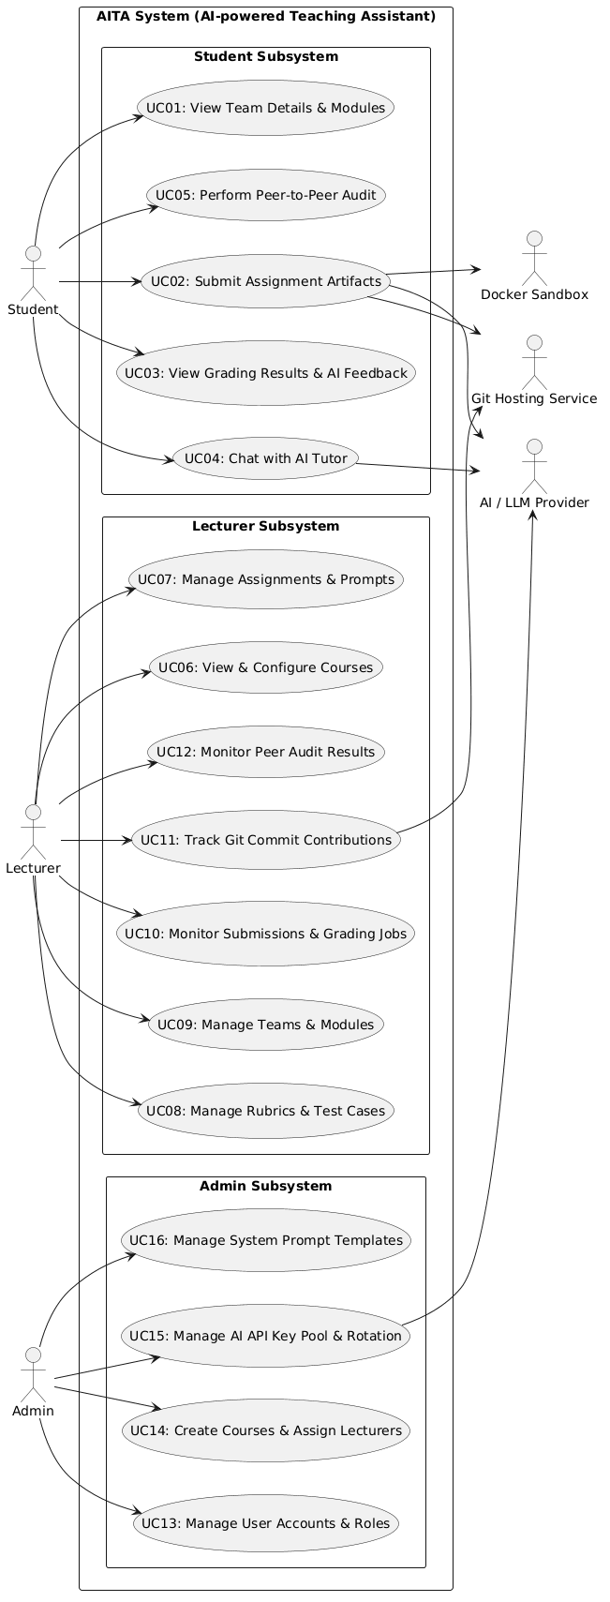

5.1.2 Student Use Case Diagram
This module focuses on functions such as viewing groups, submitting assignments, viewing results, peer grading, and chatting with AI.

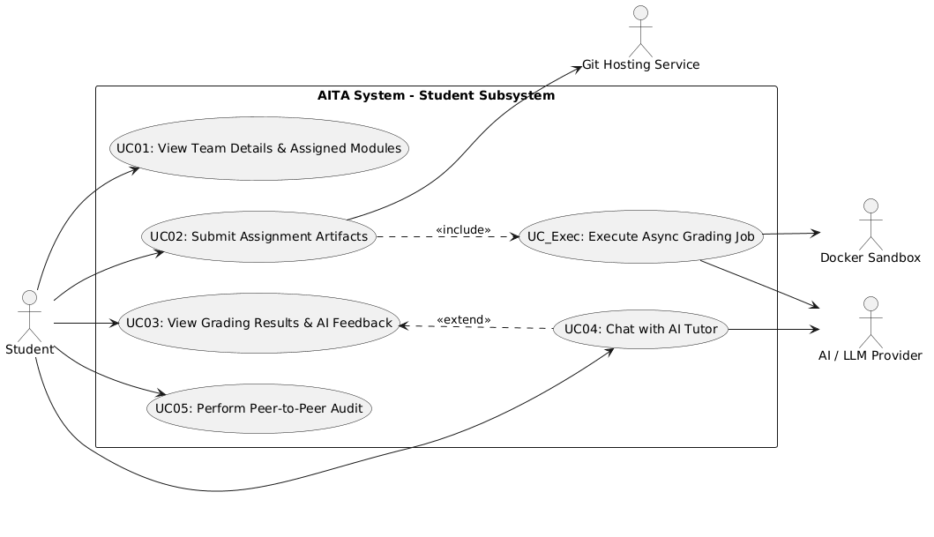
5.1.3. Lecturer Use Case Diagram
This module enables instructors to set up classes, assignments, and test case rubrics, as well as track submission progress and peer grading.
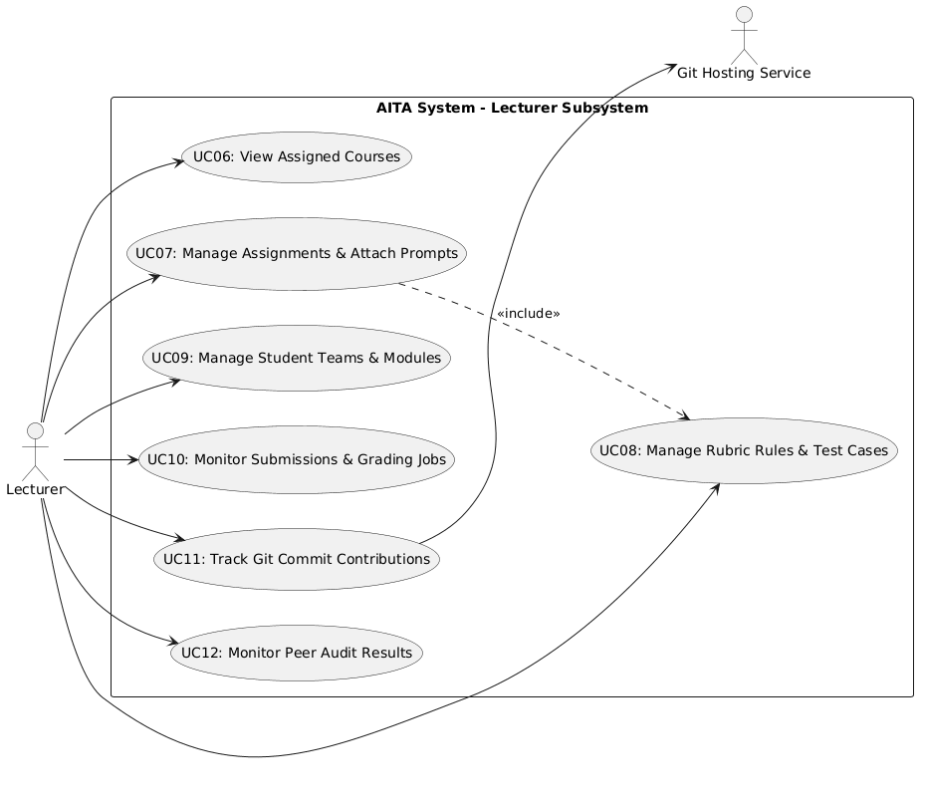
5.1.4 Admin Use Case Diagram
A module for administrators to manage accounts, create classes, and manage the API key repository and system prompt templates.

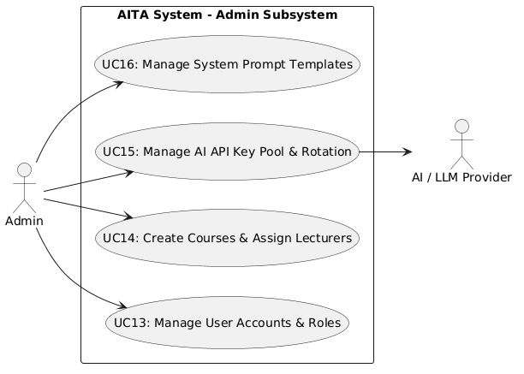

5.2 Use case descriptions
UC-01 View Team Details & Modules

Item | Specification Details
UC ID and Name: | UC-01 View Team Details & Modules
Created By: | Group 4
Primary Actor: | Student
Trigger: | The Student selects the My Team option from the course navigation menu.
Description: | This use case allows the Student to view their assigned team details, including the team name, shared repository URL (repo_url), list of team members, and individual module assignments (assigned_module).
Preconditions: | PRE-1. The Student is logged into the AITA System.  PRE-2. The Student is enrolled in an active course and assigned to a specific team by the Lecturer.
Postconditions: | POST-1. The system displays complete team details and member module assignments without modifying any database records.
Normal Flow | 1. The Student navigates to the Course Dashboard.  2. The Student clicks on the My Team tab.  3. The system queries the teams and team_members tables using the logged-in Student's user ID.  4. The system retrieves the team name, shared Git repository URL (repo_url), list of enrolled team members, and their respective assigned modules (assigned_module).  5. The system renders the team overview screen showing member profiles, role designations, and repository details.
Alternative Flows: | ALT-1: Copy Repository URL  - At step 5, the Student clicks the Copy Repo URL button.  - The system copies the repo_url string to the user's clipboard for easy Git cloning.
Exceptions: | EXC-1: Unassigned Team Status  - At step 3, if the Student is enrolled in the course but has not yet been assigned to a team by the Lecturer, the system displays "You have not been assigned to a team yet. Please contact your lecturer" and halts the process.
Priority: | Medium
Business Rules: | BR01: Students can only view team details for courses in which they are officially enrolled.  BR02: Each team member must have an assigned module designation to maintain individual accountability.

UC-02 Submit Assignment Artifacts

Item | Specification Details
UC ID and Name: | UC-02 Submit Assignment Artifacts
Created By: | Group 4
Primary Actor: | Student
Trigger: | The Student selects the Submit Assignment option on the assignment details page.
Description: | This use case allows the Student to submit their project artifact URL and Git commit hash for an active assignment, triggering the automated sandbox execution and AI grading pipeline.
Preconditions: | PRE-1. The Student is logged into the AITA System.  PRE-2. The Student belongs to an enrolled team within the course.  PRE-3. The assignment deadline has not passed.
Postconditions: | POST-1. A submission record is successfully saved in the database (submissions).  POST-2. An asynchronous grading job is queued and processed in grading_jobs.  POST-3. Evaluation results and AI feedback are populated in grading_results.
Normal Flow | 1. The Student navigates to the Assignment Detail page.  2. The system retrieves assignment requirements and displays the submission form.  3. The Student inputs the artifact_url and git_commit_hash.  4. The Student clicks the Submit button.  5. The system validates input formats and verifies the commit hash with the Git Hosting Service.  6. The system creates a new submission entry with status QUEUED.  7. The system queues a grading job with the linked prompt template and AI API key.  8. The system executes the code inside the Docker Sandbox against defined rubric rules.  9. The system calls the AI / LLM Provider to generate qualitative code feedback.  10. The system updates job status to COMPLETED and saves entries in grading_results.  11. The system displays a successful submission confirmation to the Student.

Alternative Flows: | ALT-1: Resubmission within deadline  - At step 3, if a previous submission exists, the system prompts the Student to confirm overwriting.  - Upon confirmation, the system creates a new submission version and continues to step 4.
Exceptions: | EXC-1: Invalid Git Commit Hash  - At step 5, if the Git service returns an error (commit not found), the system displays "Invalid Git commit hash. Please verify your repository" and halts the process.  EXC-2: Sandbox Execution Timeout  - At step 8, if student code exceeds the execution limit, the system marks execution as TIMEOUT, assigns zero points for automated rules, logs error details, and continues to step 9.
Priority: | High
Business Rules: | BR-1. Only one active submission per team is evaluated for final grading.  BR-2. All automated evaluations must run inside isolated containers with strictly restricted network access

UC-03 View Grading Results & AI Feedback

Item | Specification Details
UC ID and Name: | UC-03 View Grading Results & AI Feedback
Created By: | Group 4
Primary Actor: | Student
Trigger: | The Student clicks on the View Results option for a completed submission.
Description: | This use case allows the Student to view automated evaluation scores, actual test execution logs from the Docker Sandbox, and AI-generated qualitative code feedback for their submission.
Preconditions: | PRE-1. The Student is logged into the AITA System.  PRE-2. A submission record exists and the grading pipeline job status is COMPLETED.
Postconditions: | POST-1. The system renders comprehensive evaluation results without modifying data records.
Normal Flow | 1. The Student navigates to the Submissions History page.  2. The Student selects a specific submission record.  3. The system queries the submissions and grading_results tables.  4. The system retrieves rule scores, actual outputs, runtime metrics, and qualitative AI feedback (ai_feedback).  5. The system displays the score breakdown, pass/fail status per test case, and formatted Markdown AI feedback.
Alternative Flows: | ALT-1: Hidden Test Cases Filtering  - At step 4, the system checks the is_hidden attribute in rubric_rules.  - The system hides input/output details for hidden test cases, displaying only pass/fail status and earned points.
Exceptions: | EXC-1: Processing Pending  - At step 2, if the grading job status is still QUEUED or PROCESSING, the system displays "Your submission is currently being evaluated. Please refresh in a few moments" and disables detailed result view.
Priority: | Medium
Business Rules: | BR01: Students cannot view hidden test case inputs or expected outputs.  BR02: AI feedback must clearly indicate whether it was automatically generated (is_ai_generated = true).

UC-04 Chat with AI Tutor
Item | Specification Details
UC ID and Name: | UC-04 Chat with AI Tutor
Created By: | Group 4
Primary Actor: | Student
Trigger: | The Student clicks the Ask AI Tutor button on the submission results page.
Description: | This use case allows the Student to interact with the AI Tutor to receive code explanations, debugging guidance, and suggestions based on their submission evaluation results.
Preconditions: | PRE-1. The Student is logged into the AITA System.  PRE-2. A completed submission record with generated grading_results exists for the Student.
Postconditions: | POST-1. Student and AI chat messages are logged into tutor_chat_messages.  POST-2. The usage count (usage_count) for the utilized AI API key is incremented in ai_api_keys.
Normal Flow | 1. The Student opens the submission results view.  2. The system renders grading scores, actual sandbox outputs, and AI feedback.  3. The Student opens the AI Tutor chat panel and inputs a question.  4. The Student clicks Send.  5. The system logs the query in tutor_chat_messages with sender_type = 'Student'.  6. The system compiles the active prompt template, submission context, sandbox execution output, and fetches an active API key.  7. The system sends the request payload to the AI / LLM Provider.  8. The AI Provider returns the generated response formatted in Markdown.  9. The system logs the response in tutor_chat_messages with sender_type = 'AI'.  10. The system displays the formatted AI guidance on the Student's interface.

Alternative Flows: | ALT-1: API Key Auto-Rotation  - At step 7, if the active key hits a rate limit (HTTP 429) or quota error, the system automatically rotates to an active fallback API key from ai_api_keys and retries without user interruption.
Exceptions: | EXC-1: AI Provider Unavailable  - At step 7, if all available API keys fail or the external service is unreachable, the system displays "AI Tutor service is temporarily unavailable" and flags message status as failed.
Priority: | Medium
Business Rules: | BR-1. The AI Tutor must not output complete copy-paste assignment solutions; it must only provide guidance, hints, and concept explanations.

UC-05 Perform Peer-to-Peer Audit
Item | Specification Details
UC ID and Name: | UC-05 Perform Peer-to-Peer Audit
Created By: | Group 4
Primary Actor: | Student
Trigger: | The Student selects the Peer Audit option during an active audit round window.
Description: | This use case allows the Student to evaluate their team members' individual contributions by submitting peer scores, qualitative comments, and pass/fail statuses for a specific audit round.
Preconditions: | PRE-1. The Student is logged into the AITA System.  PRE-2. The peer audit round (audit_round) is active for the course.
Postconditions: | POST-1. Peer audit evaluation records are saved in the peer_audits table.
Normal Flow | 1. The Student navigates to the Peer Audit section.  2. The system retrieves team members belonging to the same team from team_members.  3. The system displays a peer audit form listing all teammates (excluding the current student).  4. The Student inputs rating scores, qualitative feedback, and pass/fail flags for each teammate.  5. The Student clicks Submit Peer Audit.  6. The system validates that all required fields are filled.  7. The system inserts audit records into peer_audits with auditor_student_id and auditee_student_id.  8. The system displays a success confirmation message.

Alternative Flows: | ALT-1: Update Existing Audit  - At step 3, if the Student has previously submitted an audit within the active window, the system populates existing scores.  - The Student updates ratings and clicks Update Audit.
Exceptions: | EXC-1: Audit Window Closed  - At step 1, if the current date exceeds the active peer audit deadline, the system displays "Peer audit window is closed" and sets the form to read-only.
Priority: | Medium
Business Rules: | BR-1. Students cannot evaluate themselves in peer audits.  BR-2. Individual audit scores given by students are strictly confidential and visible only to Lecturers.

UC-06 View & Configure Assigned Courses
Item | Specification Details
UC ID and Name: | UC-06 View & Configure Assigned Courses
Created By: | Group 4
Primary Actor: | Lecturer
Trigger: | The Lecturer logs in and accesses the Instructor Dashboard.
Description: | This use case allows the Lecturer to view courses assigned to them, inspect course configurations, and adjust course-level settings for an academic semester.
Preconditions: | PRE-1. The Lecturer is logged into the AITA System.  PRE-2. The Admin has assigned one or more courses to the Lecturer in courses.
Postconditions: | POST-1. Course configuration updates are saved in the courses table.
Normal Flow | 1. The Lecturer navigates to the Course Management section.  2. The system queries the courses table filtering by lecturer_id.  3. The system renders the list of assigned courses showing course_code, course_name, and semester.  4. The Lecturer selects a course and edits course configuration settings.  5. The Lecturer clicks Save Configuration.  6. The system validates changes and updates the course record in the database.  7. The system displays a success notification.

Alternative Flows: | ALT-1: View Archive Courses  - At step 3, the Lecturer toggles the filter to Past Semesters.  - The system displays archived course records in read-only mode.
Exceptions: | EXC-1: Duplicate Course Code Conflict  - At step 6, if a modified course code conflicts with an existing course, the system displays "Course code already exists" and prompts for correction.
Priority: | Medium
Business Rules: | BR-1. Lecturers can only view and configure courses assigned to them by the Admin.

UC-07 Manage Assignments & Prompts
Item | Specification Details
UC ID and Name: | UC-07 Manage Assignments & Prompts
Created By: | Group 4
Primary Actor: | Lecturer
Trigger: | The Lecturer selects the Manage Assignments option from the course management dashboard.
Description: | This use case allows the Lecturer to create, update, and manage course assignments, set submission deadlines and maximum scores, and link system prompt templates for AI automated grading.
Preconditions: | PRE-1. The Lecturer is logged into the AITA System.  PRE-2. The Lecturer is assigned to manage the corresponding course.
Postconditions: | POST-1. Assignment details are correctly saved in the database (assignments).  POST-2. Linked system prompt template ID (prompt_template_id) is associated with the assignment.
Normal Flow | 1. The Lecturer navigates to the Course Detail view.  2. The system retrieves and displays the list of existing assignments for the course.  3. The Lecturer selects Create New Assignment.  4. The Lecturer inputs title, description, submission deadline, and maximum score.  5. The Lecturer selects an active prompt template from the available prompt_templates list.  6. The Lecturer clicks Save Assignment.  7. The system validates the input data and verifies deadline constraints.  8. The system stores the new assignment record in assignments.  9. The system displays a success notification and updates the assignment list interface.

Alternative Flows: | ALT-1: Edit Existing Assignment  - At step 3, the Lecturer selects an existing assignment and clicks Edit.  - The system populates existing assignment data.  - The Lecturer modifies parameters and clicks Update to save changes.
Exceptions: | EXC-1: Invalid Deadline Window  - At step 7, if the specified deadline is set in the past, the system displays "Assignment deadline must be a future date" and prompts the Lecturer to re-enter.
Priority: | High
Business Rules: | BR-1. Assignments with active student submissions cannot have their maximum scores updated.  BR-2. Every assignment must be attached to a valid system prompt template before submissions can be graded.

UC-08 Manage Rubric Rules & Test Cases
Item | Specification Details
UC ID and Name: | UC-08 Manage Rubric Rules & Test Cases
Created By: | Group 4
Primary Actor: | Lecturer
Trigger: | The Lecturer selects Manage Rubrics for a specific assignment.
Description: | This use case allows the Lecturer to define, edit, and manage rubric rules, weight values, automated code test cases (input data and expected output), and hidden visibility toggles (is_hidden).
Preconditions: | PRE-1. The Lecturer is logged into the AITA System.  PRE-2. An assignment record exists in the course.
Postconditions: | POST-1. Rubric rule records and test cases are saved in rubric_rules.
Normal Flow | 1. The Lecturer selects an assignment and opens the Rubric Rules tab.  2. The system displays existing rubric rules linked to the assignment.  3. The Lecturer clicks Add Rubric Rule.  4. The Lecturer enters rule description, point weight, rule type (automated vs. manual), input data, expected output, and toggles is_hidden.  5. The Lecturer clicks Save Rule.  6. The system validates that total rubric weights equal the assignment maximum score.  7. The system creates the rubric record in rubric_rules.  8. The system updates the rubric list view.

Alternative Flows: | ALT-1: Import Standard Test Cases  - At step 3, the Lecturer chooses Import Test Case Suite.  - The system parses a uploaded JSON/YAML file and populates multiple rubric rules automatically.
Exceptions: | EXC-1: Weight Sum Mismatch  - At step 6, if the sum of rule weights exceeds or falls below the total assignment score, the system displays "Total rubric rule weights must match assignment max score" and halts saving.
Priority: | High
Business Rules: | BR-1. Hidden test cases (is_hidden = true) must be executed during grading, but their raw input/expected output data must not be exposed to students.

UC-09 Manage Student Teams & Module Assignments
Item | Specification Details
UC ID and Name: | UC-09 Manage Student Teams & Module Assignments
Created By: | Group 4
Primary Actor: | Lecturer
Trigger: | The Lecturer accesses the Team Management section of a course.
Description: | This use case allows the Lecturer to create student teams, link shared Git repository URLs, enroll students into teams, and assign individual module responsibilities (assigned_module).
Preconditions: | PRE-1. The Lecturer is logged into the AITA System.  PRE-2. Enrolled students exist in the course user list.
Postconditions: | POST-1. Team records are updated in teams and student pairings in team_members.
Normal Flow | 1. The Lecturer opens the Team Management screen.  2. The system displays existing teams and unassigned students.  3. The Lecturer clicks Create Team and enters team name and repo_url.  4. The Lecturer adds enrolled students to the team.  5. The Lecturer specifies assigned_module names for each team member.  6. The Lecturer clicks Save Team Setup.  7. The system validates team membership and repository URL syntax.  8. The system inserts/updates records in teams and team_members.  9. The system displays a confirmation message.

Alternative Flows: | ALT-1: Auto-generate Teams  - At step 3, the Lecturer clicks Auto-Generate Teams.  - The system evenly distributes unassigned students into teams of a specified size.
Exceptions: | EXC-1: Student Multi-Team Conflict  - At step 7, if a student is assigned to multiple active teams in the same course, the system displays "Student is already assigned to Team X" and prevents saving.
Priority: | Medium
Business Rules: | BR-1. A student can belong to only one team per course at any given time.

UC-10 Monitor Submissions & Asynchronous Grading Jobs

Item | Specification Details
UC ID and Name: | UC-10 Monitor Submissions & Asynchronous Grading Jobs
Created By: | Group 4
Primary Actor: | Student
Trigger: | The Lecturer accesses the Submission & Job Monitoring dashboard.
Description: | This use case allows the Lecturer to monitor real-time submission progress, track background execution job statuses (grading_jobs), view execution logs, and manually trigger job regrading.
Preconditions: | PRE-1. The Lecturer is logged into the AITA System.  PRE-2. Student team submissions exist for the course.
Postconditions: | POST-1. Updated job statuses and regraded results are stored in grading_jobs and grading_results.
Normal Flow | 1. The Lecturer navigates to the Submission Monitoring view.  2. The system queries submissions and grading_jobs tables.  3. The system renders submission timestamps, current status (QUEUED, PROCESSING, COMPLETED, FAILED), sandbox outputs, and AI feedback.  4. The Lecturer inspects detailed execution logs for a team submission.  5. If required, the Lecturer selects Re-run Grading Job.  6. The system queues a new background grading job and updates execution records.
Alternative Flows: | ALT-1: Manual Score Override  - At step 4, the Lecturer modifies points earned for a manual rubric rule.  - The system updates total scores in grading_results and logs the instructor override.
Exceptions: | EXC-1: Job Stalled in Queue  - At step 3, if a job remains in PROCESSING beyond 10 minutes, the system flags the job as STALLED and provides a Force Retry action to the Lecturer.
Priority: | High
Business Rules: | BR-1. Manual score overrides by Lecturers take precedence over automatically calculated AI/sandbox scores.

UC-11 Track Git Commit Contributions

Item | Specification Details
UC ID and Name: | UC-10 Monitor Submissions & Asynchronous Grading Jobs
Created By: | Group 4
Primary Actor: | Lecturer
Trigger: | The Lecturer selects the Contribution Analytics option for a student team.
Description: | This use case allows the Lecturer to inspect Git commit histories (git_commits), author metrics, timestamps, and lines added/deleted (lines_added, lines_deleted) to evaluate individual student contributions.
Preconditions: | PRE-1. The Lecturer is logged into the AITA System.  PRE-2. A team submission with a valid Git commit hash and repository URL exists.
Postconditions: | POST-1. Commit log details pulled from the external service are cached in git_commits.
Normal Flow | 1. The Lecturer opens the Git Contribution Analytics page for a selected team.  2. The system queries the git_commits table and connects to the Git Hosting Service.  3. The system fetches commit history, commit authors, timestamps, and code line impact statistics.  4. The system aggregates commit counts, lines_added, and lines_deleted per student based on assigned_module.  5. The system displays graphical charts and commit logs showing contribution distribution among team members.
Alternative Flows: | ALT-1: Refresh Git Commit Cache  - At step 2, the Lecturer clicks Sync Git Data.  - The system fetches the latest commits from the repository and updates git_commits.
Exceptions: | EXC-1: Repository Access Denied  - At step 3, if the Git service returns an authentication error or private repository access error, the system displays "Unable to access Git repository. Please check repo permissions" and logs the error.
Priority: | Medium
Business Rules: | BR-1. Code line impact metrics must be mapped to individual team members using their configured Git author email/username.

UC-12 Monitor Peer Audit Results

Item | Specification Details
UC ID and Name: | UC-12 Monitor Peer Audit Results
Created By: | Group 4
Primary Actor: | Lecturer
Trigger: | The Lecturer selects Peer Audit Reports from the course management dashboard.
Description: | This use case allows the Lecturer to review peer-to-peer evaluation ratings, qualitative member feedback, and pass/fail audit compliance across assessment rounds (audit_round).
Preconditions: | PRE-1. The Lecturer is logged into the AITA System.  PRE-2. Peer audit evaluations have been submitted by students in peer_audits.
Postconditions: | POST-1. Aggregated peer audit reports are generated for instructor review.
Normal Flow | 1. The Lecturer opens the Peer Audit Monitoring dashboard.  2. The system queries peer_audits grouped by team and audit_round.  3. The system calculates average peer scores, flags students marked with fail status by teammates, and lists comments.  4. The Lecturer inspects individual student evaluation matrices.  5. The system highlights teams with high variance or conflicting peer reviews for instructor intervention.
Alternative Flows: | ALT-1: Export Peer Audit Data  - At step 4, the Lecturer clicks Export CSV.  - The system generates and downloads a structured spreadsheet of all peer audit responses.
Exceptions: | EXC-1: No Audit Data Submitted  - At step 2, if no students have completed evaluations for the selected round, the system displays "No peer audit submissions found for this round".
Priority: | Low
Business Rules: | BR-1. Peer audit results are restricted exclusively to course Lecturers and Admin users.

UC-13 Manage User Accounts & Roles
Item | Specification Details
UC ID and Name: | UC-13 Manage User Accounts & Roles
Created By: | Group 4
Primary Actor: | Admin
Trigger: | The Admin accesses the User Account Management section in the admin panel.
Description: | This use case allows the System Admin to create user accounts, update profile information, reset access credentials, and assign Role-Based Access Control (RBAC) roles (Admin, Lecturer, Student).
Preconditions: | PRE-1. The Admin is logged into the AITA System with Admin privileges.
Postconditions: | POST-1. User account data and hashed passwords are updated in users.
Normal Flow | 1. The Admin navigates to the User Management dashboard.  2. The system displays a searchable list of existing system users.  3. The Admin selects Create New User.  4. The Admin inputs full name, email, role (Admin/Lecturer/Student), and initial password.  5. The Admin clicks Save User.  6. The system validates email uniqueness and hashes the password using strong encryption (e.g., bcrypt).  7. The system inserts the new user record into users.  8. The system updates the user management list.

Alternative Flows: | ALT-1: Modify Existing User Role  - At step 3, the Admin selects an existing user, changes their role designation, and clicks Update Profile.  - The system updates role permissions in users.
Exceptions: | EXC-1: Duplicate Email Address  - At step 6, if the input email already exists in users, the system displays "Email address is already registered" and prompts for a unique email.
Priority: | High
Business Rules: | BR-1. Passwords must never be stored in plaintext and must be hashed before database persistence.  BR-2. System Admins cannot delete their own active Admin account.

UC-14 Create Courses & Assign Lecturers
Item | Specification Details
UC ID and Name: | UC-14 Create Courses & Assign Lecturers
Created By: | Group 4
Primary Actor: | Admin
Trigger: | The Admin selects Course Initialization from the admin control panel.
Description: | This use case allows the System Admin to initialize new academic course records, set semester parameters, and assign responsible Lecturers (lecturer_id).
Preconditions: | PRE-1. The Admin is logged into the AITA System.  PRE-2. Lecturer user accounts exist in users.
Postconditions: | POST-1. New course records and assigned lecturer pairings are stored in courses.
Normal Flow | 1. The Admin opens the Course Administration screen.  2. The system displays existing courses and active semesters.  3. The Admin clicks Create Course.  4. The Admin enters course_code, course_name, semester, and selects a designated lecturer_id.  5. The Admin clicks Save Course.  6. The system validates course parameters and verifies lecturer account validity.  7. The system creates the course record in courses.  8. The system displays a confirmation message.

Alternative Flows: | ALT-1: Reassign Course Instructor  - At step 3, the Admin selects an existing course and updates the assigned lecturer_id.  - The system updates instructor assignments in courses.
Exceptions: | EXC-1: Unassigned Lecturer Selection  - At step 6, if no lecturer is selected, the system displays "A responsible lecturer must be assigned to the course" and halts saving.
Priority: | High
Business Rules: | BR-1. Every course must be linked to at least one valid Lecturer account.

UC-15 Manage AI API Key Pool & Rotation
Item | Specification Details
UC ID and Name: | UC-15 Manage AI API Key Pool & Rotation
Created By: | Group 4
Primary Actor: | Admin
Trigger: | The Admin selects the AI Infrastructure & Key Pool option from the admin control panel.
Description: | This use case allows the System Admin to add, update, encrypt, toggle status, and monitor usage counts of third-party AI provider API keys, as well as configure dynamic key rotation rules.
Preconditions: | PRE-1. The Admin is logged into the AITA System with Admin role privileges.
Postconditions: | POST-1. API key records are stored with AES-256 encrypted string values (key_value_encrypted) in ai_api_keys.  POST-2. Key usage counters and active status flags are updated.
Normal Flow | 1. The Admin opens the AI Key Pool Management interface.  2. The system retrieves and displays key aliases, provider names, active statuses, and usage counts (usage_count) from ai_api_keys.  3. The Admin clicks Add New API Key.  4. The Admin enters provider name (e.g., OpenAI, Gemini), key alias, and raw API key string.  5. The Admin clicks Save & Encrypt.  6. The system encrypts the raw key using AES-256 encryption (key_value_encrypted).  7. The system verifies connectivity with the AI / LLM Provider.  8. The system inserts the key record into ai_api_keys with status ACTIVE.  9. The system updates the key pool dashboard.

Alternative Flows: | ALT-1: Manual Key Deactivation  - At step 3, the Admin selects an existing key and toggles status to INACTIVE.  - The system updates key status in ai_api_keys and removes it from the active rotation queue.
Exceptions: | EXC-1: Invalid API Key Verification  - At step 7, if the AI Provider rejects the key (authentication error), the system displays "API key validation failed. Please check key validity" and aborts saving.
Priority: | High
Business Rules: | BR-1. Raw API keys must be encrypted at rest using AES-256 before saving to the database.  BR-2. The system must automatically rotate to an active fallback key upon encountering HTTP 429 rate limit errors during grading or chat operations.

UC-16 Manage System Prompt Templates
Item | Specification Details
UC ID and Name: | UC-16 Manage System Prompt Templates
Created By: | Group 4
Primary Actor: | Admin
Trigger: | The Admin opens the Prompt Template Library from the admin dashboard.
Description: | This use case allows the System Admin to create, update, version-control, and maintain system prompt templates (prompt_templates) used across AI automated grading jobs and tutoring chat sessions.
Preconditions: | PRE-1. The Admin is logged into the AITA System.
Postconditions: | POST-1. Versioned prompt template records are saved in prompt_templates.
Normal Flow | 1. The Admin navigates to the Prompt Template Management view.  2. The system lists existing prompt templates showing template name, target task (Grading vs. Tutor Chat), and version number (version).  3. The Admin clicks Create Prompt Template.  4. The Admin inputs template name, category, system prompt text, and parameter placeholders.  5. The Admin clicks Save Template.  6. The system validates placeholder syntax and increments the version counter.  7. The system inserts the record into prompt_templates.  8. The system updates the prompt template library list.

Alternative Flows: | ALT-1: Clone and Create New Version  - At step 3, the Admin selects an existing template and clicks Clone as New Version.  - The system copies prompt text, increments version (e.g., v1.0 to v1.1), and saves a new entry while retaining historical records.
Exceptions: | EXC-1: Invalid Placeholder Syntax  - At step 6, if required dynamic tags (e.g., {code_artifact}, {rubric_rules}) are missing or malformed, the system displays "Invalid prompt syntax placeholders" and requests correction.
Priority: | Medium
Business Rules: | BR-1. Historical prompt template versions linked to past grading jobs cannot be edited or deleted to preserve evaluation auditability.

5.3 Activity Diagrams

1. Activity Diagram for UC07 & UC08: Create Assignment & Configure Rubric Rules (Lecturer)
This diagram illustrates the process by which an instructor creates a new assignment, links a system prompt template, configures test case sets (visible/hidden), and verifies the total Rubric score conditions.

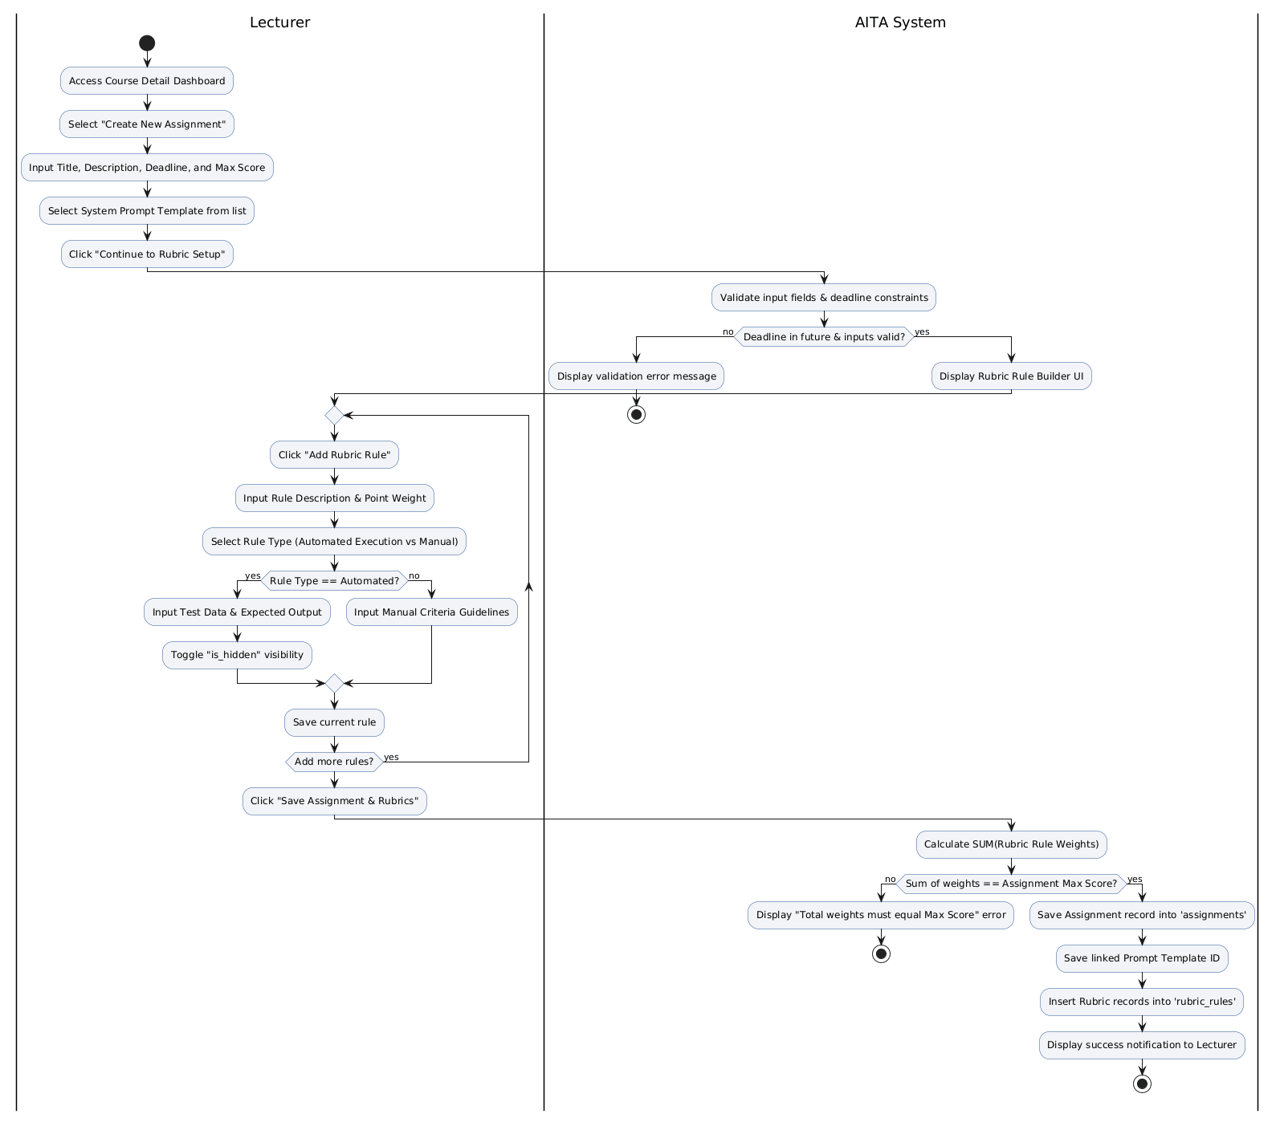

2. Activity Diagram for UC15: Manage AI API Key Pool & Key Rotation (Admin)
This diagram illustrates the process where the Administrator adds a new API key, the system automatically encrypts it using AES-256 (key_value_encrypted) and authenticates the connection to the AI ​​provider, and key rotation is handled in the event of an issue.

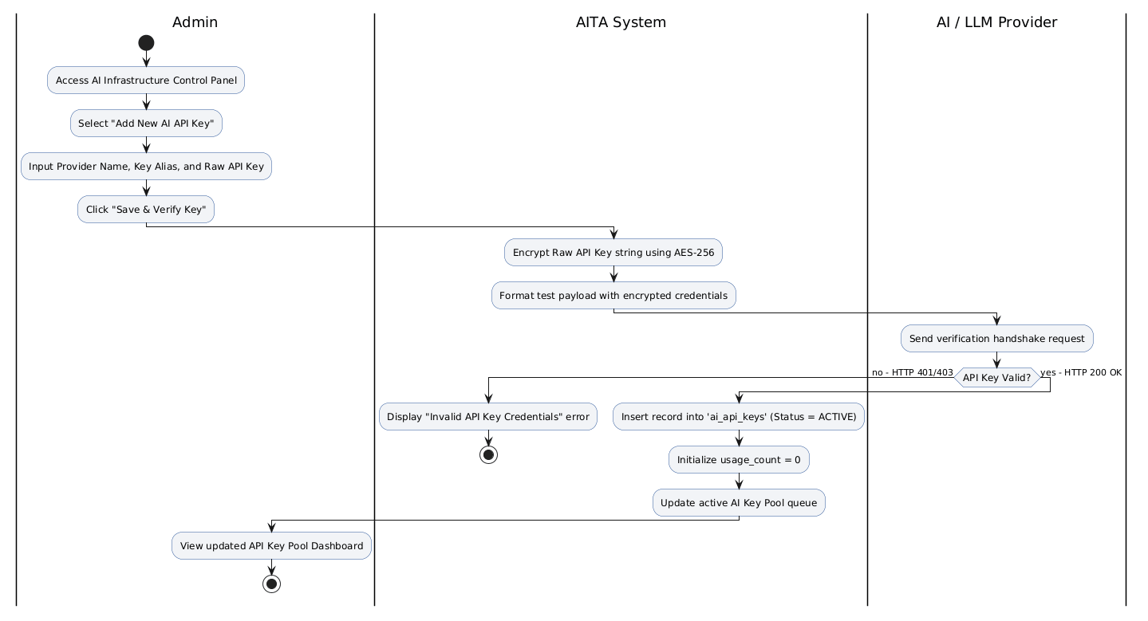

6. Data Requirements
6.1 Entity-Relationship Diagram (ERD)

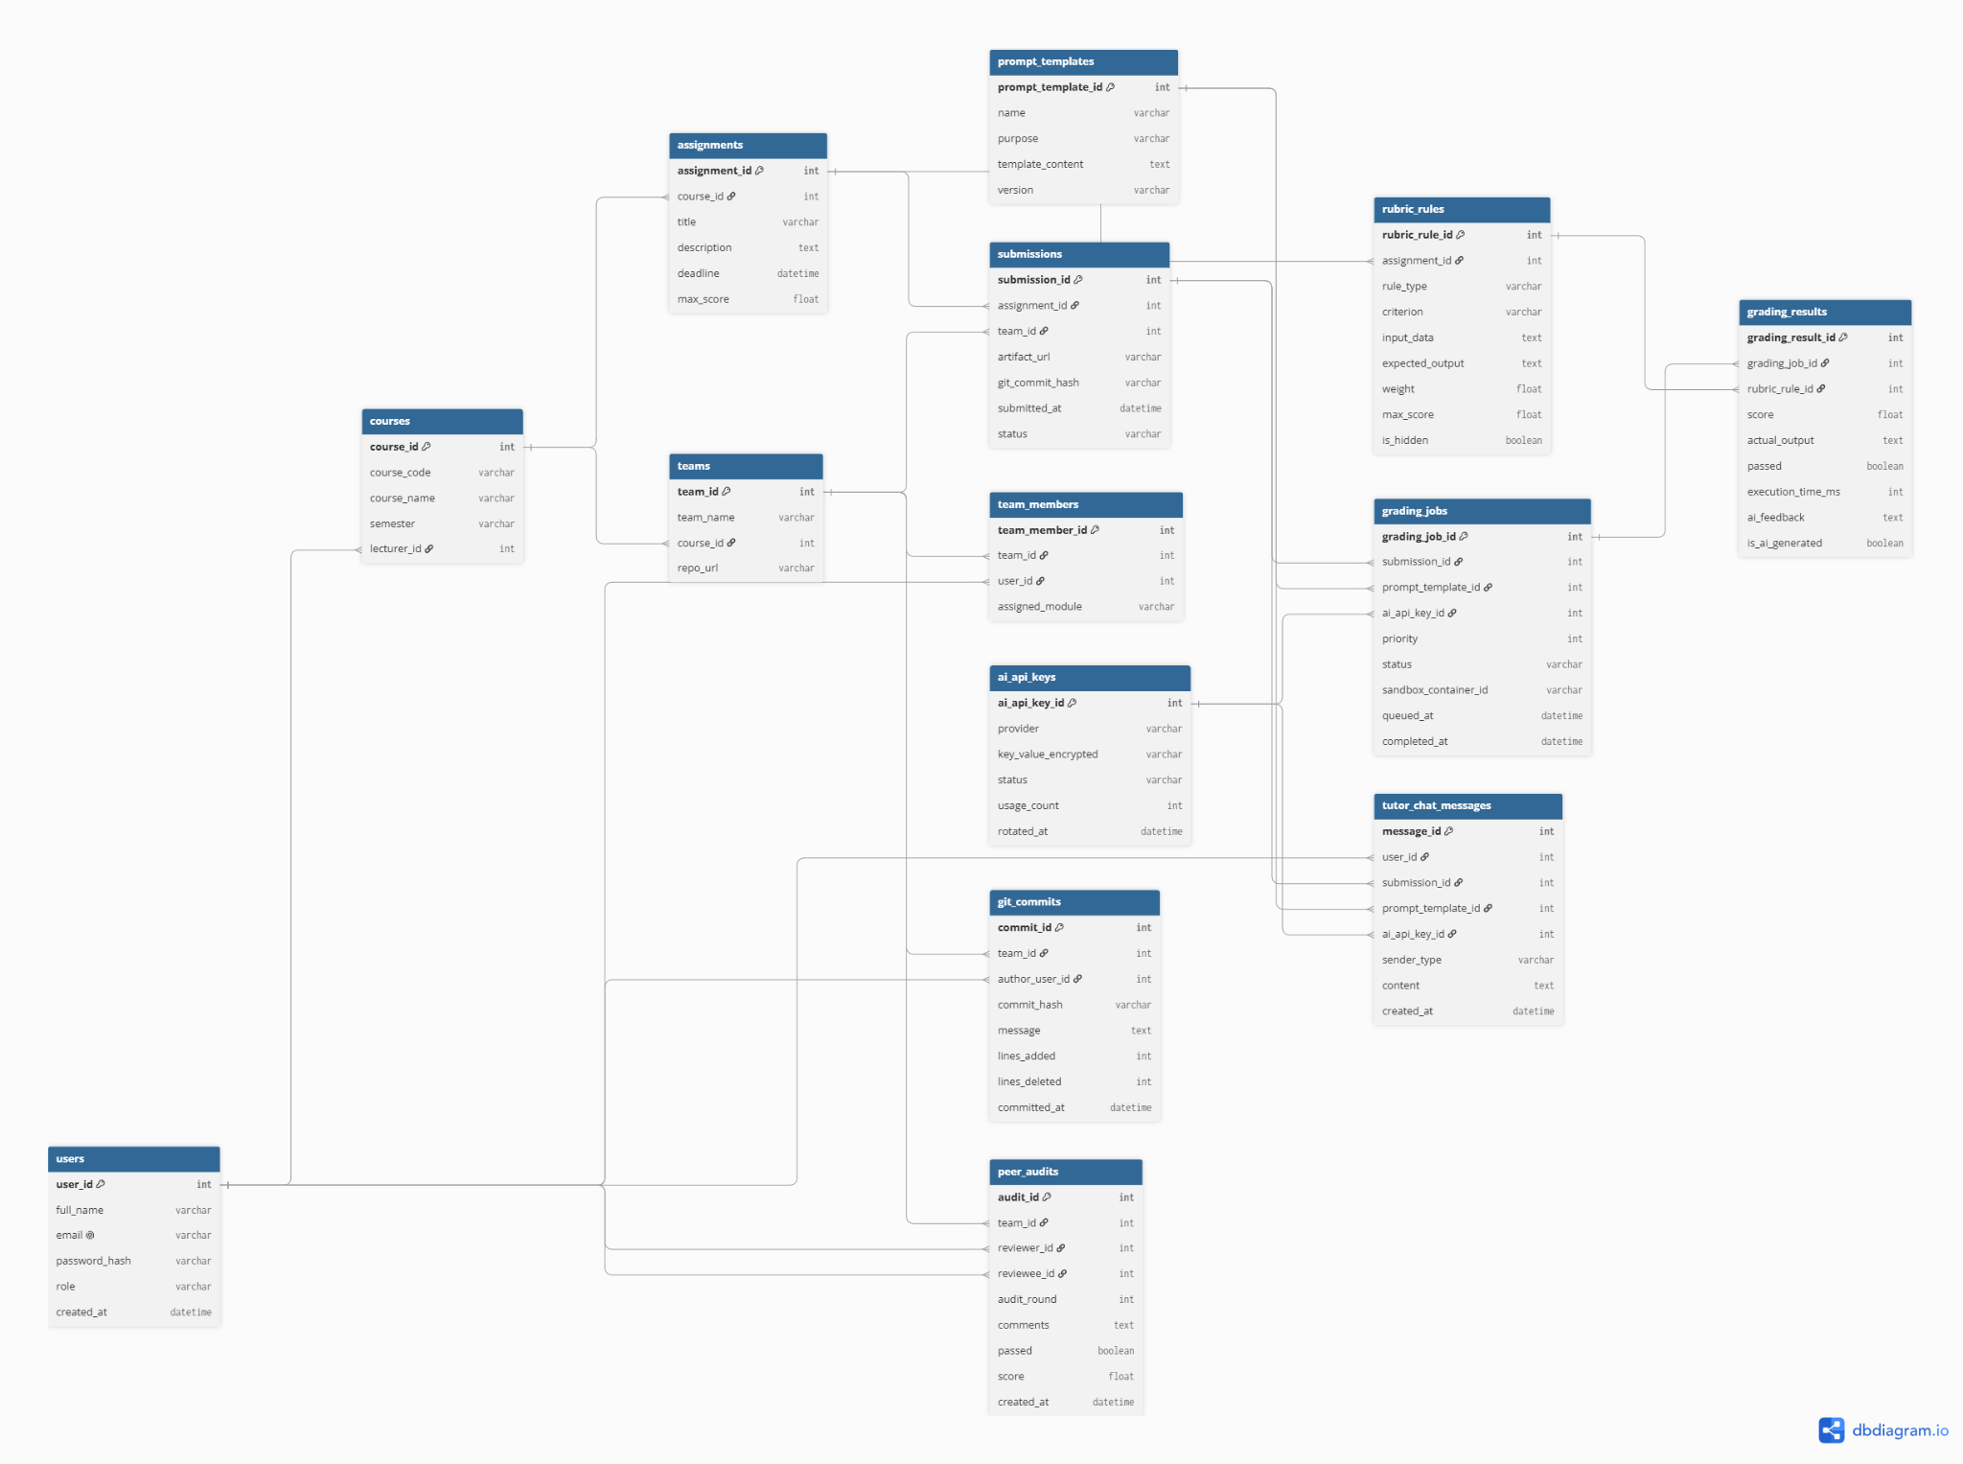
6.2 Data Dictionary

Name | Data Type | Length | Description
users |  |  | User accounts, authentication credentials, and RBAC roles
user_id | int | auto | Unique identifier for each user (Primary Key)
full_name | varchar | 100 | Full legal name of the user
email | varchar | 100 | Institutional email address (Unique)
password_hash | varchar | 255 | Hashed password string
role | varchar | 20 | System access control role (Admin, Lecturer, Student)
created_at | datetime | auto | Account creation timestamp
courses |  |  | Academic courses managed within the platform
course_id | int | auto | Unique course identifier (Primary Key)
course_code | varchar | 20 | Course code (e.g., "SWD392")
course_name | varchar | 100 | Official name of the course
semester | varchar | 10 | Academic term (e.g., "Fall 2026")
lecturer_id | int | - | Assigned instructor ID (Foreign Key)
teams |  |  | Groups of students working on collaborative projects
team_id | int | auto | Unique team identifier (Primary Key)
team_name | varchar | 50 | Team name designation
course_id | int | - | Parent course ID (Foreign Key)
repo_url |  | 255 | Shared Git repository URL
team_members |  |  | Junction table mapping students to teams and modules
team_member_id | int | auto | Unique mapping identifier (Primary Key)
team_id | int |  | Associated team ID (Foreign Key)
user_id | innt |  | Associated student ID (Foreign Key)
assigned_module | varchar | 100 | Specific subsystem/module assigned to the student
prompt_templates |  |  | Version-controlled system prompts used by LLM services
prompt_template_id | int | auto | Unique prompt template identifier (Primary Key)
name | varchar | 100 | Name of the prompt template
purpose | varchar | 100 | Target AI task purpose (e.g., Grading, TutorChat)
template_content | Text | Max | Master prompt instruction containing variables
version | Varchar | 20 | Template version string (e.g., "v1.0")
ai_api_keys |  |  | Third-party AI provider credentials and usage counters
ai_api_key_id | int | auto | Unique key identifier (Primary Key)
provider | varchar | 50 | Vendor name (e.g., OpenAI, Gemini)
key_value_encrypted | varchar | 255 | Encrypted API key string
status | varchar | 20 | Operational state (ACTIVE, INACTIVE, EXHAUSTED)
usage_count | int | - | Total API calls executed using this key
created_at | datetime | auto | Key registration timestamp
assignments |  |  | Course assignment tasks, deadlines, and scoring rules
assignment_id | int | auto | Unique assignment identifier (Primary Key)
course_id | int | - | Parent course ID (Foreign Key)
title | varchar | 100 | Assignment title
description | text | max | Detailed task instructions and requirements
deadline | datetime | - | Submission cutoff date and time
max_score | float | - | Maximum total achievable points
rubric_rules |  |  | Granular evaluation criteria and sandbox test cases
rubric_rule_id | int | auto | Unique rule identifier (Primary Key)
assignment_id | int | - | Parent assignment ID (Foreign Key)
rule_type | varchar | 20 | Evaluation method type (Automated, Manual)
criterion | text | max | Detailed rubric criteria description
input_data | text | max | Test case input payload for execution
expected_output | text | max | Expected output string for verification
weight | float | - | Weight percentage or ratio of the rule
max_score | float | - | Maximum score assigned to this rubric rule
is_hidden | Boolean | - | Flag to hide test case details from students
submissions |  |  | Student team artifact submission records
submission_id | int | auto | Unique submission identifier (Primary Key)
assignment_id | int | - | Target assignment ID (Foreign Key)
team_id | int | - | Submitting team ID (Foreign Key)
artifact_url | varchar | 255 | Submitted artifact repository link
git_commit_hash | varchar | 40 | Git commit SHA-1 hash identifier
submitted_at | datetime | Auto | Submission timestamp
status | varchar | 20 | Current submission state (SUBMITTED, GRADED)
grading_jobs |  |  | Queued background jobs for sandbox and AI evaluation
grading_job_id | int | auto | Unique job identifier (Primary Key)
submission_id | int | - | Target submission ID (Foreign Key)
prompt_template_id | int | - | Assigned prompt template ID (Foreign Key)
ai_api_key_id | int | - | Executing API key ID (Foreign Key)
priority | int | - | Processing queue priority level
status | varchar | 20 | Pipeline status (QUEUED, PROCESSING, COMPLETED, FAILED)
sandbox_container_id | varchar | 100 | Docker sandbox instance identifier
queued_at | datetime | auto | Job creation/queued timestamp
completed_at | datetime | - | Job execution completion timestamp
grading_results |  |  | Scores, execution outputs, and qualitative AI feedback
grading_result_id | int | auto | Unique result identifier (Primary Key)
grading_job_id | int | - | Source grading job ID (Foreign Key)
rubric_rule_id | int | - | Evaluated rubric rule ID (Foreign Key)
score | float | - | Points awarded for this rule
actual_output | text | max | Execution log output captured from sandbox
passed | Boolean | - | Rule pass/fail status flag
execution_time_ms | int | - | Runtime execution time in milliseconds
ai_feedback | text | maxt | Qualitative AI-generated evaluation review
is_ai_generated | Boolean | - | Flag indicating if evaluation was produced by AI
git_commits |  |  | Tracked repository commit histories and author stats
commit_id | int | auto | Unique commit record identifier (Primary Key)
team_id | int | - | Associated team ID (Foreign Key)
author_user_id | int | - | Commit author user ID (Foreign Key)
commit_hash | varchar | 40 | Git commit SHA-1 hash string
message | text | max | Git commit message content
lines_added | int | - | Number of code lines added
lines_deleted | int | - | Number of code lines deleted
committed_at | datetime | - | Original commit timestamp
peer_audits |  |  | Peer evaluation scores and feedback among team members
audit_id | int | auto | Unique peer audit record identifier (Primary Key)
team_id | int | - | Target team ID (Foreign Key)
reviewer_id | int | - | Evaluating student user ID (Foreign Key)
reviewee_id | int | - | Student user ID being evaluated (Foreign Key)
audit_round | int | - | Evaluation round number (e.g., 1, 2)
comments | text | max | Qualitative peer feedback comments
passed | Boolean | - | Pass/Fail evaluation status
score | float | - | Score awarded by peer reviewer
created_at | datetime | auto | Evaluation creation timestamp
tutor_chat_messages |  |  | Interactive AI Tutor chat logs attached to submissions
message_id | int | auto | Unique chat message identifier (Primary Key)
user_id | int | - | Message sender user ID (Foreign Key)
submission_id | int | - | Contextual submission ID (Foreign Key)
prompt_template_id | int | - | Active prompt template ID (Foreign Key)
ai_api_key_id | int | - | API key utilized for AI response (Foreign Key)
sender_type | varchar | 20 | Message author classification (Student, AI)
content | text | max | Chat prompt or AI response text content
created_at | datetime | auto | Message sent timestamp

II. Analysis models
1. Interaction diagrams
Interaction diagrams (Sequence Diagrams) illustrate how objects in the AITA system interact with one another to execute core business workflows across time.

1.1 Sequence Diagram 1: Artifact Submission & Async Sandbox Evaluation (UC02 & UC10)
- Description: Tracks the execution flow when a student submits a Git commit artifact, enqueues an asynchronous grading job, executes tests inside an isolated Docker Sandbox, and evaluates results via AI Provider.
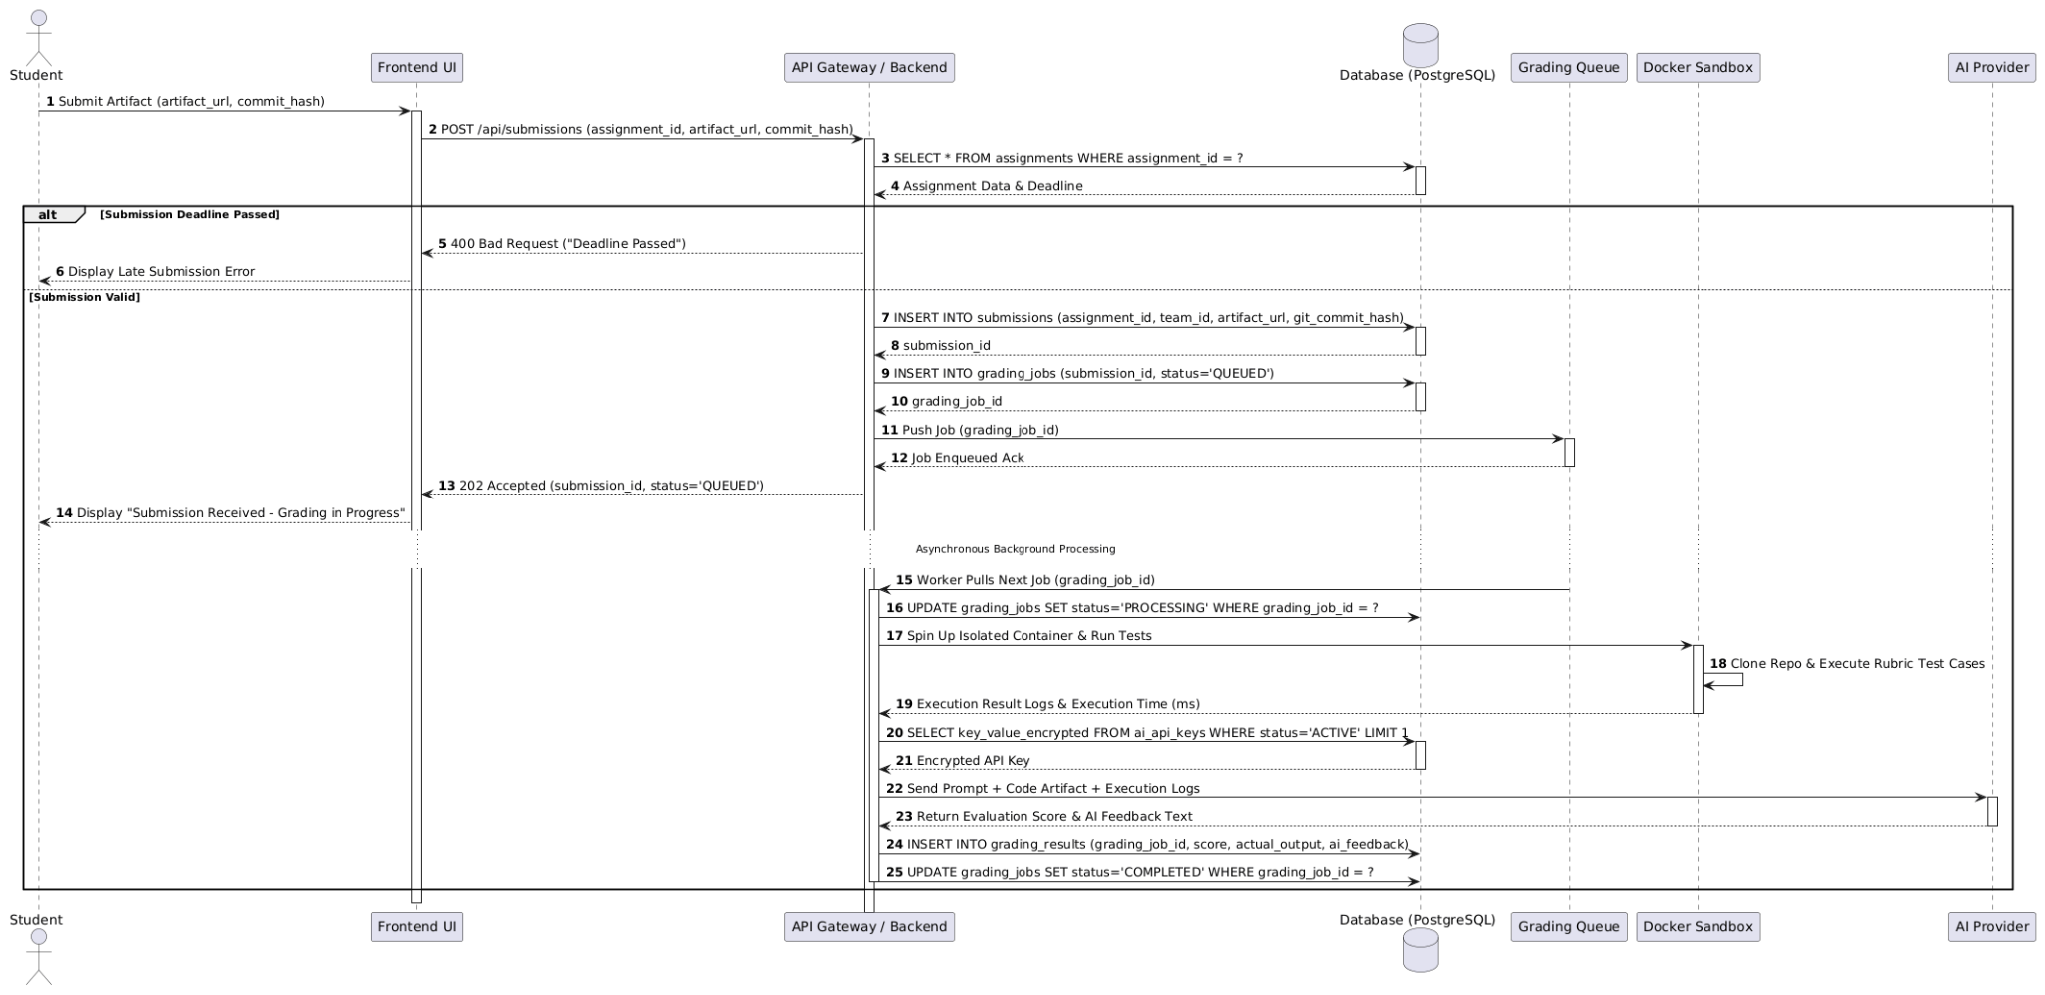

1.2 Sequence Diagram 2: Interactive AI Tutor Chat with Key Rotation (UC04 & UC15)
- Description: Demonstrates the interactive communication between a student and the AI Tutor, detailing the dynamic failover mechanism (Key Rotation) when an API key experiences rate limits (HTTP 429).
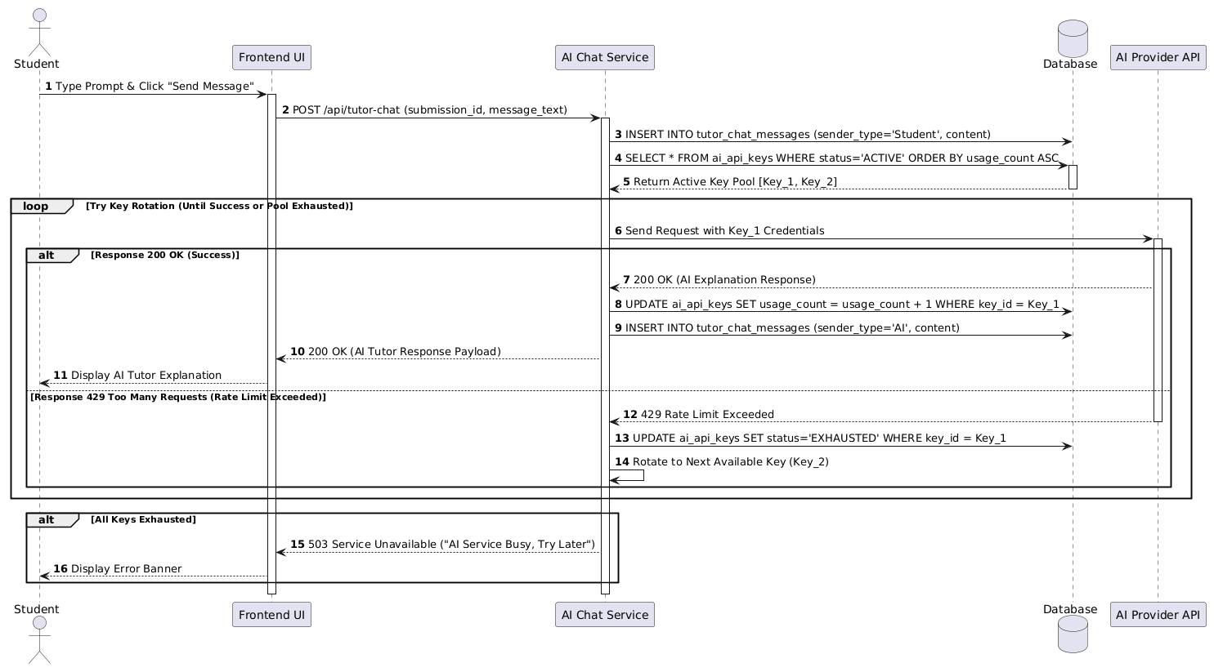

1.3 Sequence Diagram 3: Create Assignment & Configure Rubrics (UC07 & UC08)
- Description: Represents the lecturer creating an assignment, associating system prompt templates, defining automated/manual rubric rules, and validating rubric weight totals.
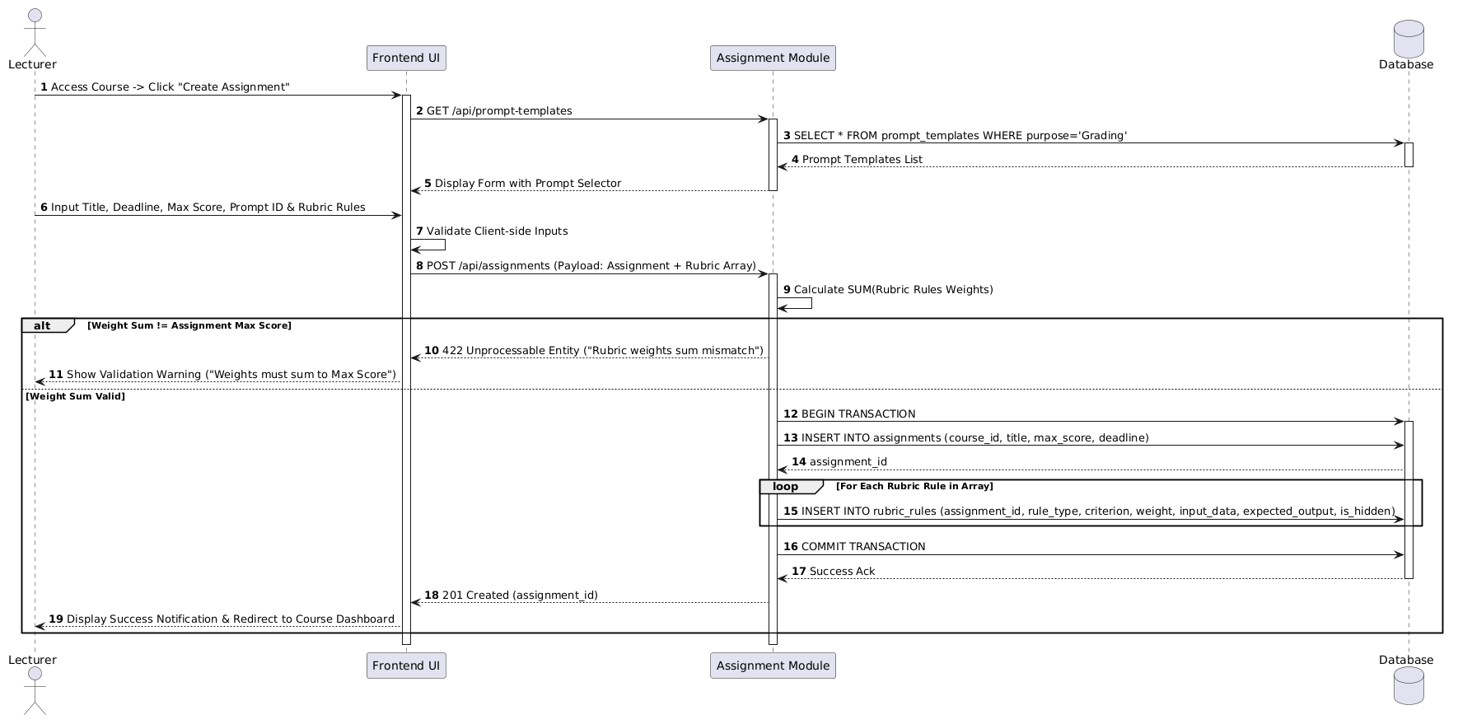

2. State diagram
State diagrams illustrate the dynamic behavior of core system entities by showing the sequence of states they occupy during their lifecycle in response to external events and internal triggers.

2.1 State Diagram for Grading Job / Submission Lifecycle
- Description: Represents the complete state transitions of a student submission and its associated asynchronous background grading job—from initial commit receipt to sandbox execution and final AI evaluation.
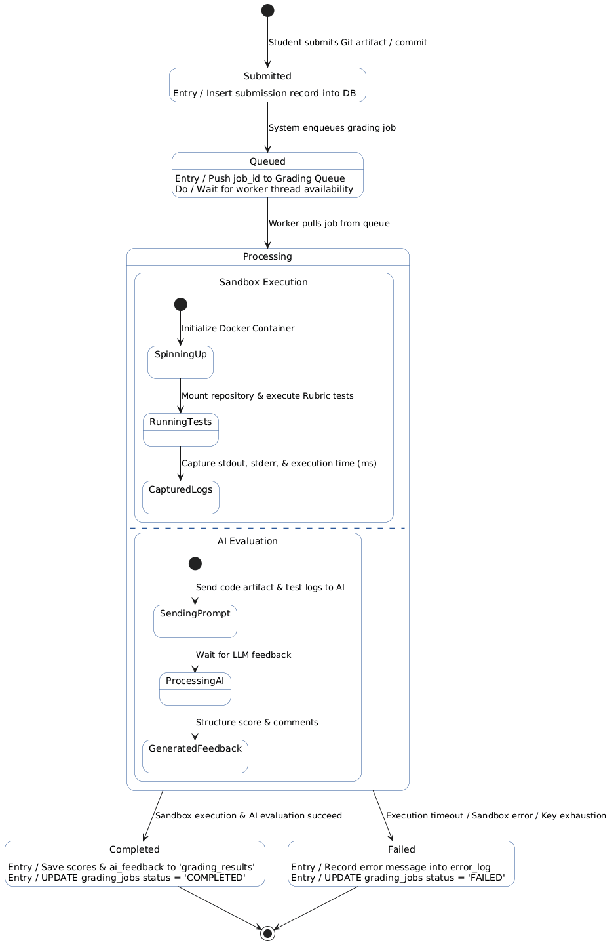

2.2 State Diagram for AI API Key Lifecycle
- Description: Details the dynamic state transitions of third-party AI API keys managed in the system's key pool—including key registration, key rotation upon hitting rate limits (HTTP 429), and pool exhaustion.
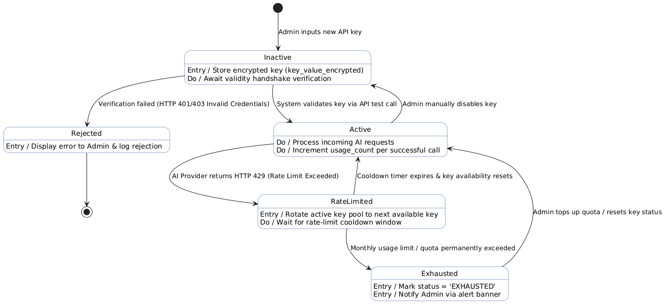

III. Design specification
- Integrated Communication Diagrams
Communication diagrams highlight the structural organization of objects that send and receive messages, illustrating object linkages along with numbered message flows for key integration scenarios.

1.1 Communication Diagram: Artifact Submission & Async Evaluation Lifecycle
- Description: Details the message exchanges between Client, Controller, Service, Async Queue, Sandbox, and AI Engine during a student's code submission and background grading process.
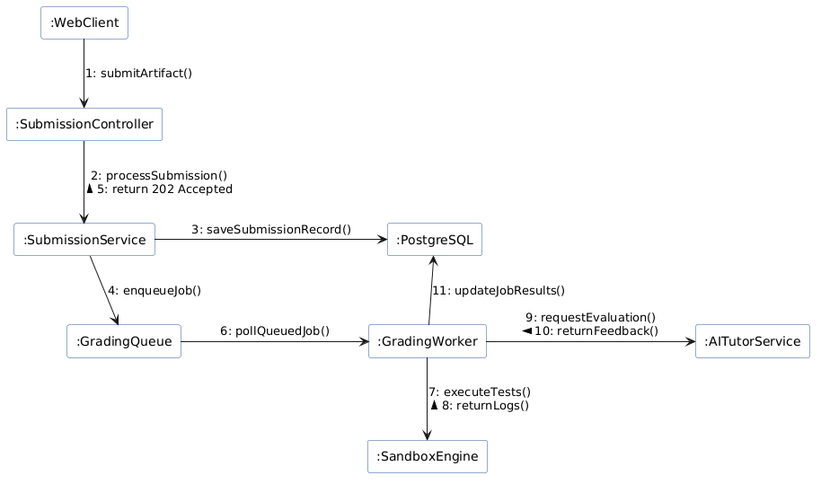1.2 Communication Diagram: AI Tutor Chat with Key Rotation
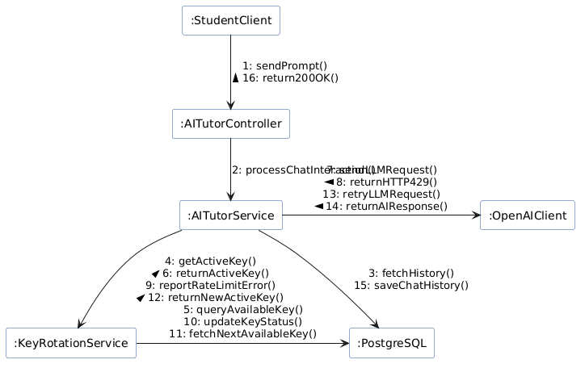

- System High-Level Design
The High-Level Architecture of AITA follows a 3-Tier Cloud-Native Architecture designed for high scalability, asynchronous processing, and secure multi-tenant execution. The design decouples web-facing REST APIs from compute-heavy tasks (Code Sandbox Execution & LLM Processing) using an asynchronous job queue.
2.1 Architectural Overview Diagram
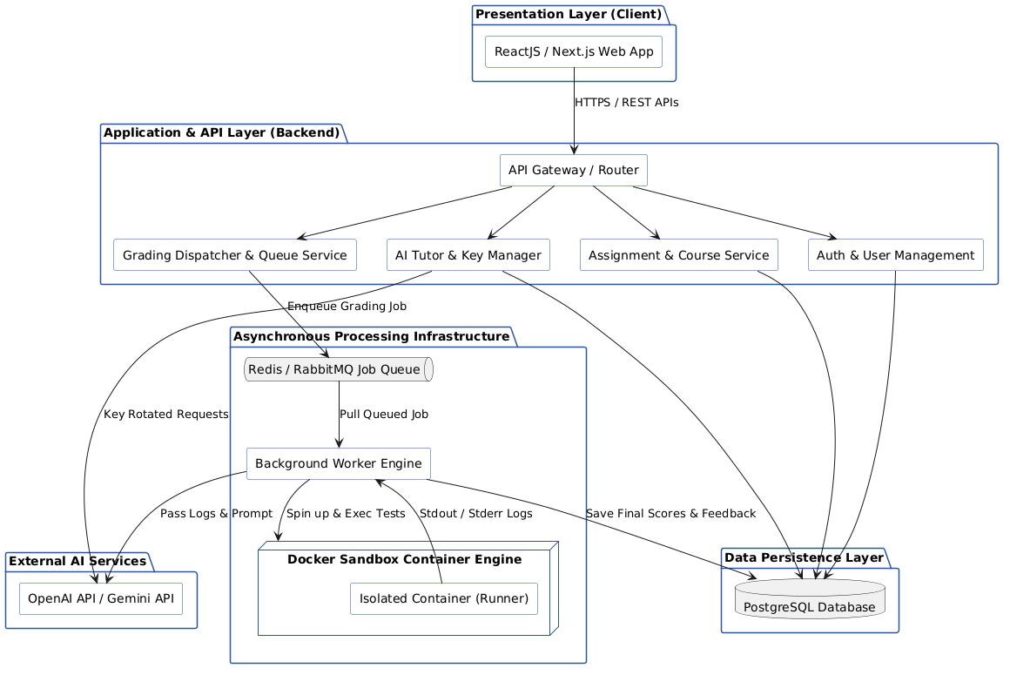

2.2 Component & Subsystem Responsibilities
1. Presentation Layer (Client App)
- Web Client (ReactJS/Next.js): Provides intuitive dashboards for Students (submit code, view AI feedback, chat with AI Tutor) and Lecturers (create assignments, configure rubric rules, setup hidden test cases).
2. Application & API Layer (Backend Core)
- API Gateway & Router: Handles HTTP request routing, CORS configuration, JWT authentication verification, and rate limiting.
- Auth & User Module: Manages RBAC (Role-Based Access Control) for Admins, Lecturers, and Students.
- Assignment & Course Module: Handles assignment definitions, criteria weighting, deadline checks, and student team mappings.
- Grading Dispatcher & Queue Service: Accepts submission payloads, creates asynchronous job records, and pushes task IDs into the execution queue.
- AI Tutor & Key Management Module: Manages prompt dynamic rendering, interactive chat histories, and key rotation algorithms across active LLM API keys.
3. Asynchronous Processing Infrastructure
- Redis / RabbitMQ Queue: Buffers grading jobs during peak submission periods (e.g., right before assignment deadlines) to prevent backend server overload.
- Background Worker Engine: Asynchronously consumes jobs from the queue, handles Docker container lifecycles, parses execution logs, and dispatches grading requests to LLMs.
- Docker Sandbox Container Engine: Executes untrusted student code inside isolated, ephemeral containers with restricted network access, CPU limits, and memory caps to ensure system safety.
4. Data Persistence & External AI Services
- PostgreSQL Database: Relational store holding all application state, structured metadata, encrypted keys, submission records, and audit trails.
- AI Provider APIs (OpenAI / Gemini): External LLMs providing qualitative code evaluation, error diagnosis, and automated feedback generation.

- Component and Package Diagram
Component and Package diagrams illustrate the logical grouping of source code artifacts into packages and detail the structural components, interfaces, and dependency relationships within the AITA system.

3.1 Package Diagram
Description: Groups system classes and modules into logical high-level packages according to software architecture layers (Controller, Service, Repository, DTO, Security, Integration).
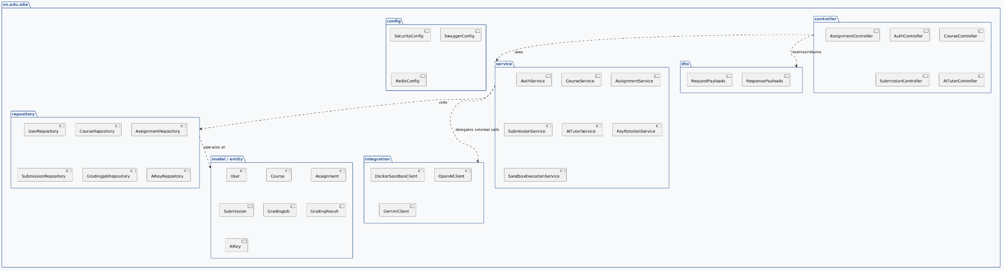

3.2 Component Diagram
Description: Details the internal software components, provided/required interfaces, and physical runtime wiring between the backend services, async queue, database, and external sandbox/AI execution engines.
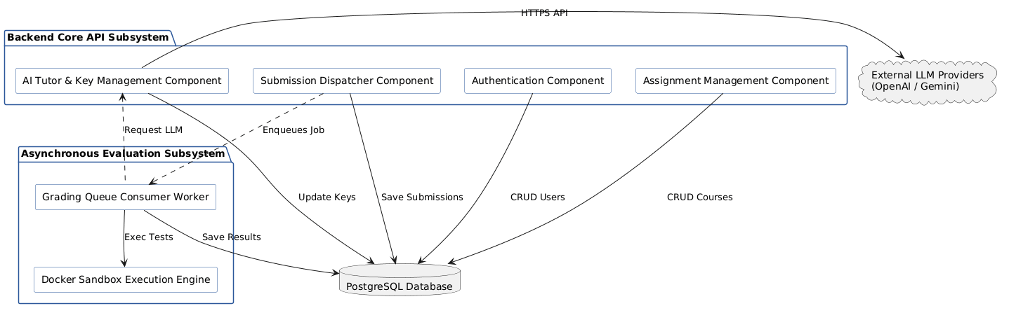

- Detail Design
This section details the internal class structure and API contracts of the AITA system, establishing the object-oriented design and interface definitions necessary for implementation.

4.1 Detailed Class Diagram
Description: Represents the system's class hierarchy, showing domain entities, data access repositories, business services, API controllers, and their association/dependency relationships.
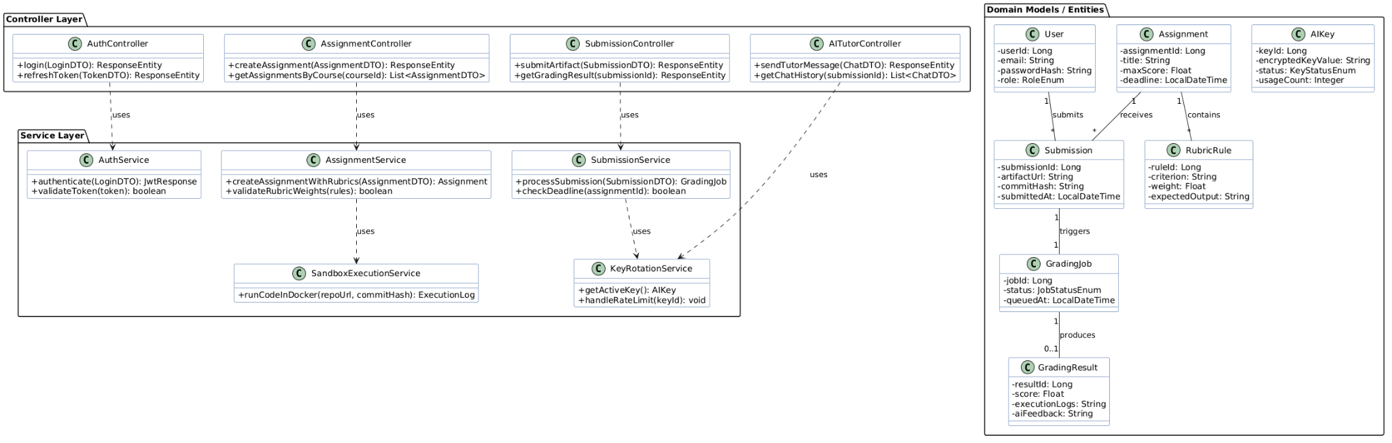

4.2 RESTful API Specification

Category | HTTP Method | Endpoint Path
Auth | POST | /api/v1/auth/login
Assignments | POST | /api/v1/assignments
Assignments | GET | /api/v1/courses/{courseId}/assignments
Submissions | POST | /api/v1/submissions
Submissions | GET | /api/v1/submissions/{submissionId}/result
AI Tutor | POST | /api/v1/tutor/chat
AI Tutor | GET | /api/v1/tutor/history/{submissionId}
Admin | POST | /api/v1/admin/ai-keys

- Database Design
This section outlines the physical database design, specifying entity relationships, primary/foreign key constraints, column data types, and indexing strategies optimized for PostgreSQL.

5.1 Physical Entity-Relationship Diagram (ERD Schema)
- Description: Details the physical relational schema, displaying primary keys (PK), foreign keys (FK), data types, and structural table constraints.
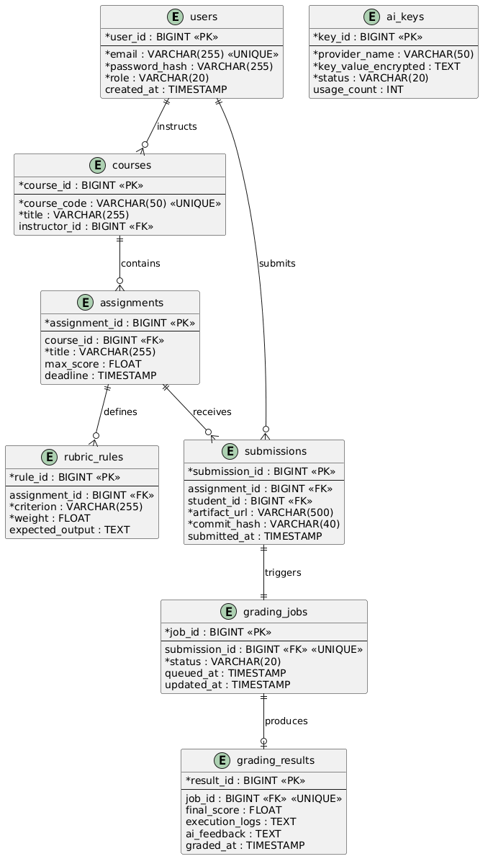
5.2 Table Constraints & Indexing Strategy

Table Name | Primary Key | Foreign Keys (FK) | Unique Constraints | Performance Indexes
users | user_id | None | email | idx_users_email
courses | course_id | instructor_id → users(user_id) | course_code | idx_courses_instructor
assignments | assignment_id | course_id→ courses(course_id) | None | idx_assignments_course_deadline
rubric_rules | rule_id | assignment_id → assignments(assignment_id) | None | idx_rubrics_assignment
submissions | submission_id | assignment_id → assignments(assignment_id)  student_id → users(user_id) | None | idx_submissions_student_assignment
grading_jobs | job_id | submission_id → submissions(submission_id) | submission_id | idx_jobs_status
grading_results | result_id | job_id → grading_jobs(job_id) | job_id | idx_results_job
ai_keys | key_id | None | None | idx_keys_status_provider

5.3 Data Integrity & Optimization Rules
- Cascade Operations: ON DELETE CASCADE được thiết lập cho rubric_rules và submissions khi assignments bị xóa để đảm bảo toàn vẹn dữ liệu.
- Encrypt at Rest: Trường key_value_encrypted trong bảng ai_keys sử dụng thuật toán AES-256 trước khi lưu vào RDBMS.
- Queue Optimization: Chỉ mục idx_jobs_status hỗ trợ các Worker truy vấn cực nhanh các công việc ở trạng thái QUEUED.

IV. Implementation
- Map architecture to the structure of the project
The system adopts a 3-Tier Layered Architecture with an asynchronous worker pipeline. Below is the direct mapping between the architectural packages specified in Section III.3 and the actual multi-module Spring Boot backend repository structure.
aita-backend/
├── src/main/java/com/fpt/aita/
│ ├── config/ # Configuration Layer (Security, CORS, Async, Swagger)
│ │ ├── SecurityConfig.java
│ │ ├── RedisQueueConfig.java
│ │ └── DockerClientConfig.java
│ │
│ ├── controller/ # Presentation Layer (REST API Endpoints)
│ │ ├── AuthController.java
│ │ ├── AssignmentController.java
│ │ ├── SubmissionController.java
│ │ └── AITutorController.java
│ │
│ ├── service/ # Business Logic Layer
│ │ ├── AuthService.java
│ │ ├── AssignmentService.java
│ │ ├── SubmissionService.java
│ │ ├── KeyRotationService.java
│ │ └── impl/ # Concrete Service Implementations
│ │
│ ├── integration/ # External Service Integration Layer
│ │ ├── DockerSandboxRunner.java
│ │ ├── OpenAIClient.java
│ │ └── QueueProducer.java
│ │
│ ├── repository/ # Data Access Layer (Spring Data JPA)
│ │ ├── UserRepository.java
│ │ ├── AssignmentRepository.java
│ │ ├── SubmissionRepository.java
│ │ └── AIKeyRepository.java
│ │
│ ├── model/ # Domain Entities (ORM Mapped to PostgreSQL)
│ │ ├── User.java
│ │ ├── Assignment.java
│ │ ├── Submission.java
│ │ ├── GradingJob.java
│ │ └── AIKey.java
│ │
│ └── dto/ # Data Transfer Objects & Request/Response Contracts
│ ├── request/
│ │ ├── SubmissionRequestDTO.java
│ │ └── TutorPromptDTO.java
│ └── response/
│ ├── GradingResultDTO.java
│ └── APIResponseDTO.java
│
└── src/main/resources/
├── application.yml # Core System & Database Configurations
└── db/migration/ # Flyway/Liquibase SQL Migration Scripts

- Map Class Diagram and Interaction Diagram to Code
Below are code implementation snippets illustrating how the domain classes and runtime interactions (Sequence Diagram SD01 & SD02) translate into production-ready Spring Boot code.

2.1 Entity & Repository Mapping (Data Layer)
Mapping the Submission and GradingJob domain entities directly from the Class Diagram and Physical ERD Schema using Spring Data JPA.
Submission.java (Domain Model)
package com.fpt.aita.model;

import jakarta.persistence.*;
import lombok.*;
import java.time.LocalDateTime;

@Entity
@Table(name = "submissions")
@Getter @Setter @NoArgsConstructor @AllArgsConstructor @Builder
public class Submission {

@Id
@GeneratedValue(strategy = GenerationType.IDENTITY)
@Column(name = "submission_id")
private Long submissionId;

@Column(name = "artifact_url", nullable = false, length = 500)
private String artifactUrl;

@Column(name = "commit_hash", nullable = false, length = 40)
private String commitHash;

@Column(name = "submitted_at")
private LocalDateTime submittedAt;

@ManyToOne(fetch = FetchType.LAZY)
@JoinColumn(name = "assignment_id", nullable = false)
private Assignment assignment;

@ManyToOne(fetch = FetchType.LAZY)
@JoinColumn(name = "student_id", nullable = false)
private User student;

@OneToOne(mappedBy = "submission", cascade = CascadeType.ALL)
private GradingJob gradingJob;
}

2.2 Sequence Diagram Mapping: Submission & Async Grading Pipeline (SD01)
This code snippet maps the message flows in SD01: SubmissionController receives the HTTP POST request, delegates processing to SubmissionService, saves metadata to PostgreSQL, and enqueues the job to Redis for background evaluation.
SubmissionController.java (REST Endpoint Mapping)
package com.fpt.aita.controller;

import com.fpt.aita.dto.request.SubmissionRequestDTO;
import com.fpt.aita.dto.response.GradingResultDTO;
import com.fpt.aita.service.SubmissionService;
import lombok.RequiredArgsConstructor;
import org.springframework.http.HttpStatus;
import org.springframework.http.ResponseEntity;
import org.springframework.web.bind.annotation.*;

@RestController
@RequestMapping("/api/v1/submissions")
@RequiredArgsConstructor
public class SubmissionController {

private final SubmissionService submissionService;

// SD01 - Step 1: submitArtifact(payload)
@PostMapping
public ResponseEntity<GradingResultDTO> submitArtifact(@RequestBody SubmissionRequestDTO request) {
// SD01 - Step 2: processSubmission(dto)
GradingResultDTO response = submissionService.processSubmission(request);

// SD01 - Step 5: return 202 Accepted (jobId)
return ResponseEntity.status(HttpStatus.ACCEPTED).body(response);
}
}

SubmissionServiceImpl.java (Business Logic & Interaction Execution)
package com.fpt.aita.service.impl;

import com.fpt.aita.dto.request.SubmissionRequestDTO;
import com.fpt.aita.dto.response.GradingResultDTO;
import com.fpt.aita.integration.QueueProducer;
import com.fpt.aita.model.*;
import com.fpt.aita.repository.*;
import com.fpt.aita.service.SubmissionService;
import lombok.RequiredArgsConstructor;
import org.springframework.stereotype.Service;
import org.springframework.transaction.annotation.Transactional;

import java.time.LocalDateTime;

@Service
@RequiredArgsConstructor
public class SubmissionServiceImpl implements SubmissionService {

private final SubmissionRepository submissionRepository;
private final GradingJobRepository gradingJobRepository;
private final QueueProducer queueProducer;

@Override
@Transactional
public GradingResultDTO processSubmission(SubmissionRequestDTO dto) {
// Build Entity from DTO
Submission submission = Submission.builder()
.artifactUrl(dto.getArtifactUrl())
.commitHash(dto.getCommitHash())
.submittedAt(LocalDateTime.now())
.build();

// SD01 - Step 3: saveSubmissionRecord()
Submission savedSubmission = submissionRepository.save(submission);

GradingJob job = GradingJob.builder()
.submission(savedSubmission)
.status(JobStatusEnum.QUEUED)
.queuedAt(LocalDateTime.now())
.build();

GradingJob savedJob = gradingJobRepository.save(job);

// SD01 - Step 4: enqueueJob(jobId)
queueProducer.enqueueGradingJob(savedJob.getJobId());

return GradingResultDTO.builder()
.submissionId(savedSubmission.getSubmissionId())
.jobId(savedJob.getJobId())
.status(savedJob.getStatus().name())
.build();
}
}

2.3 Sequence Diagram Mapping: AI Tutor Chat with Key Rotation (SD02)
This snippet illustrates the failover handling from SD02: KeyRotationService retrieves an active API key, attempts LLM execution, catches RateLimitException (HTTP 429), rotates the key status in PostgreSQL, and retries with a fresh key seamlessly.
KeyRotationServiceImpl.java (Failover Mechanism Mapping)
package com.fpt.aita.service.impl;

import com.fpt.aita.model.AIKey;
import com.fpt.aita.model.KeyStatusEnum;
import com.fpt.aita.repository.AIKeyRepository;
import com.fpt.aita.service.KeyRotationService;
import lombok.RequiredArgsConstructor;
import org.springframework.stereotype.Service;
import org.springframework.transaction.annotation.Transactional;

@Service
@RequiredArgsConstructor
public class KeyRotationServiceImpl implements KeyRotationService {

private final AIKeyRepository aiKeyRepository;

// SD02 - Step 5: queryAvailableKey()
@Override
public AIKey getActiveKey() {
return aiKeyRepository.findFirstByStatusOrderByUsageCountAsc(KeyStatusEnum.ACTIVE)
.orElseThrow(() -> new RuntimeException("No active AI keys available in key pool"));
}

// SD02 - Step 10: updateKeyStatus(EXHAUSTED/RATE_LIMITED)
@Override
@Transactional
public void handleRateLimit(Long keyId) {
AIKey key = aiKeyRepository.findById(keyId)
.orElseThrow(() -> new IllegalArgumentException("Invalid Key ID"));

key.setStatus(KeyStatusEnum.RATE_LIMITED);
aiKeyRepository.save(key);
}
}

V. Applying Alternative Architecture Patterns
This section explores an alternative architectural style for the AITA System by transitioning from the monolithic 3-Tier structure to a Service-Oriented Architecture (SOA) / Microservices Architecture. It details service decomposition, dynamic service lookup via the Service Discovery Pattern, and routing mechanisms designed to enhance scalability and fault tolerance.

1. Applying the Service-Oriented Architecture (SOA)
In an SOA approach, the monolithic core backend is decoupled into independent, loosely coupled, and highly reusable services organized around specific business domains. Each service manages its own domain logic and data storage boundary.

1.1 Service Decomposition Strategy
The system is decomposed into 5 primary core services:
- Identity & Access Service (auth-service): Handles user registration, authentication, OAuth2 token issuance, and RBAC authorization.
- Assignment & Course Service (course-service): Manages course rosters, assignment metadata, and rubric rule configurations.
- Submission & Evaluation Service (submission-service): Handles student artifact uploads, interacts with Redis queues, and manages execution job statuses.
- Execution Sandbox Worker (sandbox-service): A lightweight consumer service that pulls code execution requests, spins up Docker containers, and executes unit tests.
- AI Tutor & Key Management Service (ai-service): Manages LLM prompt generation, API key pools, failover rotation, and chat interaction logs.

1.2 SOA Architecture Diagram
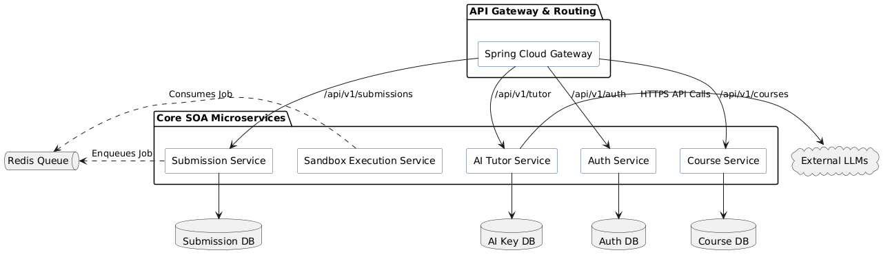

2. Applying Service Discovery Pattern in SOA
In a distributed SOA environment, microservices run inside containers (e.g., Docker/Kubernetes) where IP addresses and port numbers are assigned dynamically. Hardcoding service endpoints leads to fragile systems.
The Service Discovery Pattern solves this by establishing a central Service Registry (Eureka Server) where service instances automatically register and query network locations at runtime.

2.1 Service Discovery Lifecycle & Architecture
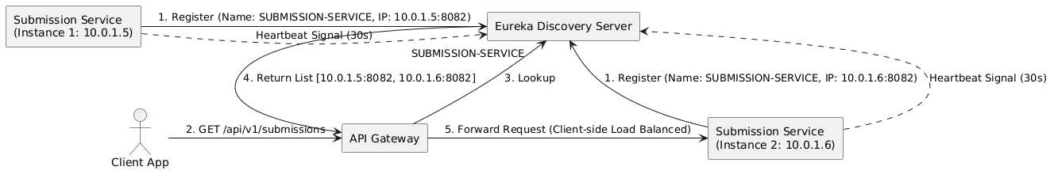

2.2 Code Implementation Snippets for Service Discovery

Step 1: Eureka Discovery Server Configuration
The central registry server that manages active microservice instances.
DiscoveryServerApplication.java
package com.fpt.aita.discovery;

import org.springframework.boot.SpringApplication;
import org.springframework.boot.autoconfigure.SpringBootApplication;
import org.springframework.cloud.netflix.eureka.server.EnableEurekaServer;

@SpringBootApplication
@EnableEurekaServer // Enables Service Registry Server
public class DiscoveryServerApplication {
public static void main(String[] args) {
SpringApplication.run(DiscoveryServerApplication.class, args);
}
}
application.yml (Registry Config)
server:
port: 8761

eureka:
instance:
hostname: localhost
client:
registerWithEureka: false # Discovery server doesn't register with itself
fetchRegistry: false
serviceUrl:
defaultZone: http://${eureka.instance.hostname}:${server.port}/eureka/

Step 2: Service Provider Registration (submission-service)
Each microservice automatically registers its dynamic IP and port upon startup.
SubmissionServiceApplication.java
package com.fpt.aita.submission;

import org.springframework.boot.SpringApplication;
import org.springframework.boot.autoconfigure.SpringBootApplication;
import org.springframework.cloud.client.discovery.EnableDiscoveryClient;

@SpringBootApplication
@EnableDiscoveryClient // Automatically registers with Eureka
public class SubmissionServiceApplication {
public static void main(String[] args) {
SpringApplication.run(SubmissionServiceApplication.class, args);
}
}
application.yml (Client Service Config)
spring:
application:
name: submission-service # Service Name registered in Eureka Server

server:
port: 0 # Dynamic port allocation for horizontal scaling

eureka:
client:
serviceUrl:
defaultZone: http://localhost:8761/eureka/
instance:
preferIpAddress: true

Step 3: Dynamic Inter-Service Routing with WebClient & Load Balancer
Microservices communicate with each other using logical service names (e.g., http://submission-service) instead of hardcoded IP addresses.
WebClientConfig.java
package com.fpt.aita.ai.config;

import org.springframework.cloud.client.loadbalancer.LoadBalanced;
import org.springframework.context.annotation.Bean;
import org.springframework.context.annotation.Configuration;
import org.springframework.web.reactive.function.client.WebClient;

@Configuration
public class WebClientConfig {

@Bean
@LoadBalanced // Enables Ribbon/Spring Cloud LoadBalancer for automatic round-robin
public WebClient.Builder loadBalancedWebClientBuilder() {
return WebClient.builder();
}
}

AIServiceImpl.java (Making Inter-Service Calls)

package com.fpt.aita.ai.service;

import lombok.RequiredArgsConstructor;
import org.springframework.stereotype.Service;
import org.springframework.web.reactive.function.client.WebClient;

@Service
@RequiredArgsConstructor
public class AIServiceImpl {

private final WebClient.Builder webClientBuilder;

public Object fetchSubmissionDetails(Long submissionId) {
// Resolves "submission-service" dynamically via Eureka Registry
return webClientBuilder.build()
.get()
.uri("http://submission-service/api/v1/submissions/{id}", submissionId)
.retrieve()
.bodyToMono(Object.class)
.block();
}
}
2.3 Trade-off Analysis: Monolithic 3-Tier vs. Service-Oriented Architecture (SOA)

Evaluation Criteria | Monolithic 3-Tier Architecture | Service-Oriented Architecture (SOA)
Complexity | Low development & deployment complexity. Single codebase. | High operational complexity (requires Gateway, Registry, Distributed Tracing).
Scalability | Scale the entire monolith horizontally. Resource inefficient. | Scale specific bottleneck services independently (e.g., scale sandbox-service 10x).
Fault Isolation | Single error/memory leak can crash the entire application. | High fault isolation; failure in ai-service does not stop student submission flows.
Data Management | Single unified database (PostgreSQL). ACID transactions. | Database per service (Polyglot Persistence). Requires Eventual Consistency (Saga Pattern).
Deployment Speed | Redeploy whole application for minor bug fixes. | Continuous deployment per microservice without downtime.

